Cognishield: Edge-Based Adversarial Immunization for Digital Media

BITE497J – Project I

Submitted in partial fulfillment of the requirements for the degree of

Bachelor of Technology
in
Information Technology

by

23BIT0030 – ROHIT KUMAR
23BIT0067 – SHIVANSH RAI
23BIT0241 – AVIRAL BHAN

Under the guidance of

Dr. Angulakshmi M

School of Computer Science Engineering and Information Systems
VIT, Vellore


November, 2026

Cognishield: Edge-Based Adversarial Immunization for Digital Media

BITE497J – Project I

Submitted in partial fulfillment of the requirements for the degree of

Bachelor of Technology
in
Information Technology

by

23BIT0030 – ROHIT KUMAR
23BIT0067 – SHIVANSH RAI
23BIT0241 – AVIRAL BHAN

Under the guidance of

Dr. Angulakshmi M

School of Computer Science Engineering and Information Systems
VIT, Vellore

November, 2026
DECLARATION

We hereby declare that the BITE497J – Project I thesis entitled “Cognishield: Edge-Based Adversarial Immunization for Digital Media” submitted by us, for the award of the degree of Bachelor of Technology in Information Technology, School of Computer Science Engineering and Information Systems to VIT is a record of bonafide work carried out by us under the supervision of Dr. Angulakshmi M, SCORE, VIT, Vellore.
We further declare that the work reported in this thesis has not been submitted and will not be submitted, either in part or in full, for the award of any other degree or diploma in this institute or any other institute or university.

Place: Vellore
Date:

Signature of the Candidate

Rohit Kumar (23BIT0030)
Shivansh Rai (23BIT0067)
Aviral Bhan (23BIT0241)

CERTIFICATE
This is to certify that the BITE497J – Project I thesis entitled “Cognishield: Edge-Based Adversarial Immunization for Digital Media” submitted by Rohit Kumar (23BIT0030), Shivansh Rai (23BIT0067) & Aviral Bhan (23BIT0241), SCORE, VIT, for the award of the degree of Bachelor of Technology in Information Technology, School of Computer Science Engineering and Information Systems, is a record of bonafide work carried out by them under my supervision during the period, 06.07.2026 to 03.11.2026, as per the VIT code of academic and research ethics.
The contents of this report have not been submitted and will not be submitted either in part or in full, for the award of any other degree or diploma in this institute or any other institute or university. The thesis fulfills the requirements and regulations of the University and in my opinion meets the necessary standards for submission.

Place: Vellore
Date:

Signature of the Guide
Dr. Angulakshmi M

Internal Examiner External Examiner

Head of the Department
Department of Information Technology

ACKNOWLEDGEMENT

It is our pleasure to express with a deep sense of gratitude to our BITE497J – Project I guide Dr. Angulakshmi M, School of Computer Science Engineering and Information Systems, Vellore Institute of Technology, Vellore for constant guidance and continual encouragement in our endeavor. Our association with the guide is not confined to academics only, but it is a great opportunity on our part to work with an intellectual and an expert in the field of Image Security and Adversarial Machine Learning.

We would like to express our heartfelt gratitude to Honorable Chancellor Dr. G Viswanathan; respected Vice Presidents Dr. Sankar Viswanathan, Dr. Sekar Viswanathan, Vice Chancellor Dr. V. S. Kanchana Bhaaskaran; Pro-Vice Chancellor Dr. Partha Sharathi Mallick; and Registrar Dr. Jayabarathi T.

Our whole-hearted thanks to Dean Dr. Daphne Lopez, School of Computer Science Engineering and Information Systems, Head, Department of Information Technology, Dr. Arivuselvan K, Information Technology Project Coordinator Dr. Suganya P, SCORE School Project Coordinator Dr. Karthikeyan P, all faculty, staff and members working as limbs of our university for their continuous guidance throughout our course of study in unlimited ways.

It is indeed a pleasure to thank our parents and friends who persuaded and encouraged us to take up and complete our project successfully. Last, but not least, we express our gratitude and appreciation to all those who have helped us directly or indirectly towards the successful completion of the project.

Place: Vellore
Date: Rohit Kumar, Shivansh Rai, Aviral Bhan

Executive Summary
Generative image models can edit a downloaded photograph within seconds, yet most defences detect fakes only after the harm is done. This project presents CogniShield, a local prototype that protects an image before it is shared. The tool adds a seeded, edge-aware, high-frequency perturbation limited to at most 8 of 255 intensity levels, refines it with feedback from the real JPEG encoder, measures PSNR, SSIM, MSE and absolute differences, tests JPEG robustness at several qualities, and signs the protected PNG with Ed25519 over a SHA-256 digest so that tampering is detectable. A Flask web interface and command-line tools run entirely on the user's computer, and an optional module compares SD-Turbo image-to-image outputs for the original and protected images. On 14 test images the mean PSNR was 41.56 dB and the mean SSIM 0.9800; protection took about 0.27 s per image, results were reproducible, and all 18 recorded manifests matched their files. About half of the perturbation survived JPEG qualities 95 and 75, but little survived quality 50 or rescaling, and no visible disruption of SD-Turbo was observed. CogniShield is therefore a transparent, measurable baseline for stronger model-aware protection, not a guarantee of immunity.
CONTENTS Page
No.
Acknowledgement i
Executive Summary ii
Table of Contents iii
List of Figures v
List of Tables vii
Abbreviations ix
Symbols and Notations x
1 INTRODUCTION 1
1.1 Objective 2
1.2 Motivation 3
1.3 Background 4
1.4 Organization of the Report 8
2 PROJECT DESCRIPTION AND GOALS 9
2.1 Problem Statement 9
2.2 Scope of the Project 10
2.3 Threat Model 10
2.4 Goals and Objectives 12
2.5 System Overview 12
2.6 Literature Survey 13
2.7 Research Gap and Contribution 14
2.8 Deliverables 14
2.9 Use Cases and Requirement Traceability 15
3 TECHNICAL SPECIFICATION 17
3.1 Hardware Requirements 17
3.2 Software Requirements 17
3.3 Libraries and Dependencies 18
3.4 Functional Requirements 18
3.5 Non-Functional Requirements 19
3.6 System Architecture 19
3.7 Interface Specification 21
3.8 Data Specification 22
3.9 Environment Setup 23
3.10 Output Tree of a Run 24
3.11 Assumptions and Dependencies 24
4 DESIGN APPROACH AND DETAILS 26
4.1 Design Approach / Materials & Methods 26
4.2 Codes and Standards 39
4.3 Constraints, Alternatives and Tradeoffs 40
5 SCHEDULE, TASKS AND MILESTONES 43
5.1 Work Breakdown 43
5.2 Timeline 43
5.3 Milestones 44
5.4 Risks and Mitigation 44
5.5 Quality Assurance and Review Practice 45
6 PROJECT DEMONSTRATION 46
6.1 Demonstration Setup 46
6.2 Walkthrough of the Web Interface 46
6.3 Demonstration 1: Portrait Protection 47
6.4 Demonstration 2: JPEG Variants 49
6.5 Demonstration 3: Signed Provenance 49
6.6 Demonstration 4: SD-Turbo Target Test 50
6.7 Demonstration 5: Other Images 51
6.8 Demonstration 6: Command-Line and Batch Workflow 52
6.9 Behaviour in Error Situations 53
7 COST ANALYSIS / RESULT & DISCUSSION 54
7.1 Experimental Setup 54
7.2 Imperceptibility of the Protection 56
7.3 Effect of the Perturbation Budget 57
7.4 Effect of the Compression Feedback 58
7.5 Robustness to JPEG Compression 61
7.6 Robustness to Other Transformations 63
7.7 Edge-Aware Allocation of the Perturbation 64
7.8 Reproducibility and Seed Sensitivity 65
7.9 Provenance Verification 66
7.10 Effect on the SD-Turbo Target Model 67
7.11 Running Time and Scalability 68
7.12 Discussion 68
7.13 Cost Analysis 70
7.14 Ethical and Societal Considerations 71
8 SUMMARY 72
8.1 Summary of the Work 72
8.2 Key Findings 73
8.3 Limitations 74
8.4 Recommendations and Future Work 74
8.5 Conclusion 75
9 REFERENCES 77
APPENDIX A

List of Figures

Figure No. | Title | Page No.
1.1 | Reactive Detection Versus Proactive Immunization | 8
2.1 | Threat Model and Actors in the CogniShield Scenario | 10
2.2 | System Context of CogniShield | 13
3.1 | Layered Software Stack of CogniShield | 20
3.2 | Module Structure of the CogniShield Library | 20
3.3 | Sequence of Calls for a Protection Request | 21
4.1 | End-to-End Processing Pipeline of CogniShield | 27
4.2 | Flowchart of the Protection Algorithm with JPEG Feedback | 30
4.3 | Signing and Verification Protocol of the Provenance Module | 33
4.4 | Process Isolation of the Optional SD-Turbo Test | 35
4.5 | Level-One Data Flow Diagram of CogniShield | 37
5.1 | Project Timeline from 06 July to 03 November 2026 | 44
6.1 | Schematic Layout of the CogniShield Web Interface | 47
6.2 | Portrait Run at the Default Settings: Original, Protected, Difference ×12 and Noise Preview | 48
6.3 | Protected Portrait After JPEG Compression at Qualities 95, 75 and 50 | 49
6.4 | SD-Turbo Image-to-Image Outputs for the Original and the Protected Portrait | 51
6.5 | Difference Between the Two SD-Turbo Outputs, Magnified Twelve Times, and Its Histogram | 51
6.6 | Protection of a Colour Portrait From the Sample Data | 52
6.7 | Protection of a Handwritten Notebook Page | 52
7.1 | Contact Sheet of the 14 Test Images | 55
7.2 | PSNR and SSIM of the Protected Images at the Default Settings | 56
7.3 | Distribution of Pixel Changes for the Colour Portrait (Budget 8/255) | 57
7.4 | Effect of the Perturbation Budget on PSNR, SSIM and Maximum Change | 58
7.5 | Effect of the Number of Feedback Iterations on PSNR and Perturbation Retention | 59
7.6 | Correlation of the Final Perturbation With the Initial Noise and With the Image's Own JPEG Residual | 60
7.7 | Mean PSNR and SSIM After JPEG Compression, With and Without Protection | 62
7.8 | Mean Perturbation Retention Under Compression and Filtering (Error Bars Show One Standard Deviation) | 64
7.9 | Ratio of Mean Perturbation at Edges to Mean Perturbation in Flat Areas | 65
7.10 | PSNR of the Portrait Image for Ten Different Seeds | 66
7.11 | Protection Time Versus Image Size | 68

List of Tables

Table No. | Title | Page No.
1.1 | Detection, Provenance and Immunization Compared | 7
1.2 | Organization of the Report | 8
2.1 | Scope of the Prototype | 10
2.2 | Attack Scenarios and Expected Outcomes | 12
2.3 | Project Goals and Acceptance Criteria | 12
2.4 | Related Work and Position of CogniShield | 13
2.5 | Use Cases | 15
2.6 | Traceability From Goals to Requirements and Evidence | 16
3.1 | Hardware Requirements | 17
3.2 | Software Requirements | 18
3.3 | Python Libraries and Their Roles | 18
3.4 | Functional Requirements | 19
3.5 | Non-Functional Requirements | 19
3.6 | Responsibilities of the Library Modules | 21
3.7 | HTTP Endpoints of the Web Application | 22
3.8 | Protection Controls and Their Effects | 22
3.9 | Command-Line Programs and Options | 22
3.10 | Folder Layout of the Project | 23
3.11 | Fields of the Provenance Manifest | 23
4.1 | Quality Measures Reported by CogniShield | 32
4.2 | Worked Example on a 4 × 4 Patch of the Colour Portrait (Red Channel, Default Settings) | 39
4.3 | Standards Followed by the Implementation | 40
4.4 | Design Constraints | 40
4.5 | Design Alternatives and Reasons for the Choices Made | 41
5.1 | Work Breakdown Structure | 43
5.2 | Project Milestones and Evidence of Completion | 44
5.3 | Risk Register | 44
6.1 | Steps of a Demonstration Session | 47
6.2 | Metrics of the Portrait Run (Budget 8/255, Four Iterations, Seed 42) | 49
6.3 | Functional Test Cases and Expected Behaviour | 53
7.1 | Test Images Used in the Experiments | 54
7.2 | Imperceptibility Metrics at the Default Settings (ε = 8/255, 4 Iterations, Seed 42) | 56
7.3 | Effect of the Perturbation Budget ε (Mean of 4 Images, 4 Iterations) | 58
7.4 | Effect of the Number of Compression-Feedback Iterations (Mean of 4 Images, ε = 8/255) | 59
7.5 | Composition of the Final Perturbation at the Default Settings | 60
7.6 | Mean Effect of JPEG Compression With and Without Protection (14 Images) | 61
7.7 | Quality of the Protected Image After JPEG Compression, Compared With the Original | 62
7.8 | Perturbation Retention ρ After JPEG Compression for Each Image | 62
7.9 | Perturbation Retention ρ Under Common Transformations (6 Images) | 63
7.10 | Edge-Aware Allocation of the Perturbation (Values on the 0–1 Pixel Scale) | 65
7.11 | Seed Sensitivity on the Portrait Image (ε = 8/255, 4 Iterations) | 66
7.12 | Provenance Integrity Results | 67
7.13 | SD-Turbo Test on the Portrait Image | 67
7.14 | Protection Time Versus Image Size (Three Runs, Median) | 68
7.15 | Assessment Against the Project Goals | 69
7.16 | Software and Resource Cost for the Prototype | 70

List of Abbreviations

AI Artificial Intelligence
API Application Programming Interface
APA American Psychological Association (referencing style)
CLI Command-Line Interface
CPU Central Processing Unit
CSS Cascading Style Sheets
CSV Comma-Separated Values
CUDA Compute Unified Device Architecture
DCT Discrete Cosine Transform
DDPM Denoising Diffusion Probabilistic Model
EdDSA Edwards-curve Digital Signature Algorithm
FGSM Fast Gradient Sign Method
GPU Graphics Processing Unit
HTML HyperText Markup Language
HTTP HyperText Transfer Protocol
JPEG Joint Photographic Experts Group
JSON JavaScript Object Notation
MAE Mean Absolute Error (mean absolute delta)
MSE Mean Squared Error
MVP Minimum Viable Product
PEM Privacy-Enhanced Mail (text key encoding)
PGD Projected Gradient Descent
PNG Portable Network Graphics
PSNR Peak Signal-to-Noise Ratio
RGB Red, Green, Blue
SD Stable Diffusion
SHA Secure Hash Algorithm
SSIM Structural Similarity Index Measure
UI User Interface
UTC Coordinated Universal Time
WEBP Web Picture Format

Symbols and Notations

ε Perturbation budget (maximum absolute change per pixel, 0–1 scale)
E Perturbation budget in 8-bit levels, ε = E/255
δ Perturbation added to the original image
x Original image (floating-point array in [0, 1])
x_p Protected image
ξ Raw seeded Gaussian noise field
n Normalised high-frequency noise
m Edge mask
w Edge weight (default 0.65)
g Gradient magnitude of the grey-level image
λ Compression weight (default 0.16)
N Number of feedback iterations
Q Set of JPEG qualities used in the feedback loop
J_q JPEG round trip at quality q
f_k Compression residual at iteration k
ρ_T Perturbation retention under transformation T
r Ratio of edge to flat perturbation
μ, σ Local mean and standard deviation (SSIM)
H, W Image height and width in pixels
h SHA-256 digest of the protected file
σ_sig Ed25519 signature
CHAPTER 1
INTRODUCTION
Digital images have become the default way in which people record events, express identity and build trust online. A single photograph posted to a social platform can be copied, edited and re-shared within minutes, usually without the knowledge of the person who took it or the person who appears in it. For most of the history of digital photography this was a manageable risk, because convincing manipulation required skill, time and specialised software. That barrier has now collapsed. Generative image models based on diffusion can take an ordinary photograph, add controlled noise to it and denoise it again under a text prompt, producing a new image that keeps the identity and layout of the original but changes its content. A few lines of code, or a single button in a web interface, are enough to turn a harmless portrait into a fabricated scene.
The response of the research and industry community to this problem has largely been reactive. Deepfake detectors, forensic classifiers and platform moderation pipelines try to decide, after a manipulated image already exists, whether it is real. Detection is valuable, but it is an arms race: every improvement in a generator removes artefacts that a detector relied upon, and a detector can only act after the harmful content has been created and often after it has been seen. A complementary and less explored idea is to act before the image is published. If the owner of a photograph could make a small, almost invisible change to the file that disturbs the way generative models interpret it, and could attach a cryptographic proof that the published file is the one they released, then the burden would shift from catching fakes to making fakes harder and traceable.
This report describes CogniShield, a local prototype that implements this idea for still images. CogniShield takes an input image on the user's own machine and produces a protected copy in which every pixel differs from the original by at most a user-selected budget, typically 8 out of 255 intensity levels. The perturbation is built from seeded high-frequency noise, concentrated on edges and textured regions where it is least visible, and refined through a feedback loop that anticipates JPEG compression, the transformation that almost every shared image undergoes. The tool then measures how close the protected image remains to the original using PSNR, SSIM, mean squared error and absolute pixel differences, tests how the protected image behaves after JPEG compression at several quality levels, and finally signs the exact bytes of the protected file with an Ed25519 signature computed over a SHA-256 digest. An optional module sends the original and the protected image through a locally installed SD-Turbo image-to-image model so that the effect on a real generative model can be inspected side by side.
The work was carried out as the BITE497J Project I of the B.Tech. programme in Information Technology at the School of Computer Science Engineering and Information Systems, VIT, Vellore. The software is written in Python 3.12, uses Flask for a browser-based interface that runs entirely on the local machine, and is also available as command-line tools for single-image and batch processing. Chapter 1 introduces the objective, motivation and technical background. Chapter 2 defines the problem, scope, threat model and goals and reviews related work. Chapter 3 gives the technical specification, and Chapter 4 describes the design and algorithms in detail. Chapter 5 presents the schedule and milestones, Chapter 6 demonstrates the working system, and Chapter 7 reports the quantitative results, discussion and cost analysis. Chapter 8 summarises the findings, and Chapter 9 lists the references.
1.1 Objective
The overall objective of this project is to design, implement and evaluate a local, edge-based system that immunizes digital images against misuse by generative models and attaches verifiable provenance to the protected output. The system must work on an ordinary computer, must not upload the user's image to any external service, and must report honestly how much protection it provides and what that protection costs in visual quality.
This overall objective is divided into the following specific objectives:
- To generate a protected version of an input image by adding a bounded, seeded, edge-aware, high-frequency perturbation whose maximum per-pixel change is controlled by a single budget parameter.
- To make the perturbation aware of lossy compression by feeding the residual of JPEG round trips back into the perturbation for a configurable number of iterations.
- To quantify the visual cost of protection with PSNR, SSIM, mean squared error, mean absolute delta and maximum absolute delta, and to compare the protected image with the original after JPEG compression at qualities 95, 85, 75, 60 and 50.
- To create cryptographic provenance for every protected image by hashing the file with SHA-256, signing the digest with an Ed25519 private key stored locally, and recording the result in a portable JSON manifest that can be verified later.
- To provide an optional evaluation module that passes the original and protected images through a local SD-Turbo image-to-image pipeline with identical prompt and seed so that the behaviour of a real generative model can be compared.
- To package the pipeline as a responsive web interface and as command-line tools so that the system can be demonstrated, reproduced and extended by other students and researchers.
The success of the project is judged against the review metrics suggested at the outset: PSNR should generally stay above 30 dB and SSIM should stay close to 1.0 for the protected image, JPEG robustness must be reported at qualities 95, 75 and 50, and the comparison of original and protected target-model outputs must be available for inspection. Chapter 7 reports how the finished prototype performs against each of these criteria.
1.2 Motivation
Three developments motivate this work. The first is the accessibility of image-to-image generation. Latent diffusion models released with open weights can run on a consumer graphics card, and distilled variants such as SD-Turbo produce a result in one to four denoising steps. An attacker no longer needs a training set, a cluster or expertise: a downloaded photograph and a prompt are sufficient. Because image-to-image generation starts from the victim's actual photograph, the output inherits the victim's face, pose and background, which is precisely what makes it convincing and harmful.
The second is the asymmetry between creation and detection. A manipulated image can be created in seconds, but proving that it is fake requires specialised tools and expert interpretation, and the proof usually arrives after the image has spread. Even when a detector is accurate on the data it was trained on, its accuracy is known to drop on content produced by new generators and on images that have been recompressed or resized by social platforms. A defence that only reacts therefore leaves the victim permanently one step behind. Immunization changes the economics: a small amount of computation by the image owner, performed once before upload, can increase the effort required from every later attacker.
The third is privacy and control. Many existing protection services require the user to upload the photograph they wish to protect, which means that the very image a person is worried about is sent to a third party. A tool that runs at the edge, on the user's own computer, removes that contradiction. CogniShield processes the image locally, stores its outputs and keys in project folders on the same machine, and serves its interface only at the loopback address 127.0.0.1.
There is also a practical, pedagogical motivation. Adversarial machine learning, applied cryptography and web engineering are usually taught separately. This project joins them in a single, inspectable pipeline of about one thousand lines of Python in which every stage can be run, measured and explained, which makes it a suitable vehicle for studying the trade-offs between imperceptibility, robustness and verifiability that real systems must balance.
Finally, the project is motivated by honesty about what protection can and cannot achieve. Claims that an image is "immune" to manipulation are easy to make and hard to defend. The review-oriented design of CogniShield therefore emphasises measurement: every output is accompanied by metrics, the effect on the target model is shown rather than asserted, and the limitations are reported explicitly in Chapters 7 and 8.
1.3 Background
1.3.1 Generative models and image editing
Modern image generators are dominated by diffusion models. A denoising diffusion probabilistic model learns to reverse a gradual noising process: during training, images are corrupted with Gaussian noise over many steps and a neural network learns to predict the noise, and during generation the network is applied repeatedly to turn pure noise into an image (Ho et al., 2020). Latent diffusion moves this process from pixel space into the compact latent space of an autoencoder, which makes high-resolution synthesis affordable and underlies the Stable Diffusion family of models (Rombach et al., 2022).
Editing an existing photograph with such a model is conceptually simple. In the approach known as SDEdit, the input image is first perturbed with a controlled amount of noise and then denoised under a new prompt, so that coarse structure from the input is preserved while details are regenerated (Meng et al., 2022). The amount of noise is controlled by a strength parameter between 0 and 1: a low value preserves almost everything, and a high value gives the model more freedom. Open-source toolkits expose this as an image-to-image pipeline, and it is exactly the operation that CogniShield uses as its target. SD-Turbo is a distilled model that applies adversarial diffusion distillation to compress the sampling process into very few steps (Sauer et al., 2023), which makes it a practical and fast target for local experiments.
1.3.2 Adversarial examples and image immunization
Neural networks are known to be sensitive to small, deliberately chosen perturbations. Szegedy et al. (2014) showed that imperceptible changes can cause an image classifier to output a wrong label, and Goodfellow et al. (2015) explained this with the linear behaviour of networks in high dimensions and proposed the fast gradient sign method. The central formulation is a constrained optimisation: find a perturbation δ of bounded magnitude that maximises a loss, as written in Eqn. 1.1, where the bound ε controls the largest permitted change to any pixel.
$\max_{δ} L\left(f(x+δ),y\right) s.t. {\left\|δ\right\|}_{∞}≤ε$ (1.1)
The fast gradient sign method takes a single step in the direction of the sign of the gradient, as in Eqn. 1.2. Iterating this step with projection onto the allowed set gives projected gradient descent, which is widely used as a strong first-order attack (Madry et al., 2018), and Kurakin et al. (2017) showed that such perturbations can survive printing and re-photographing.
$x^{'}=x+ε·sign\left(∇_{x}L(f(x),y)\right)$ (1.2)
The same machinery can be turned into a defensive tool. If the "model" being attacked is the generative pipeline that an adversary will use to edit a photograph, then a perturbation that disrupts the encoder or the denoiser can make the edit fail or look unrealistic. This idea is called immunization in PhotoGuard (Salman et al., 2023), which perturbs an image so that diffusion-based editing produces unrealistic results. Related systems protect against other misuse: Fawkes cloaks personal photographs so that face-recognition models trained on them are misled (Shan et al., 2020), Glaze protects artists against style mimicry (Shan et al., 2023), Anti-DreamBooth protects against personalised fine-tuning of text-to-image models (Van Le et al., 2023), and AdvDM generates adversarial examples for diffusion models to prevent painting imitation (Liang et al., 2023). These systems generally rely on gradient access to a particular target model and on substantial computation, often on a GPU.
1.3.3 Lossy compression and its effect on perturbations
Almost every image that is shared online is stored or transmitted in a lossy format. JPEG divides an image into 8 × 8 blocks, applies a discrete cosine transform, divides the coefficients by a quantisation table whose coarseness is set by a quality factor, and entropy-codes the result (Wallace, 1991). High-frequency coefficients are quantised most aggressively because the eye is least sensitive to them, and this is precisely where small adversarial perturbations tend to reside. Dziugaite et al. (2016) observed that JPEG compression can undo much of the effect of small adversarial perturbations, and Shin and Song (2017) proposed generating perturbations with a differentiable approximation of JPEG so that they survive compression. CogniShield addresses the same issue in a lightweight way by repeatedly encoding the candidate image with the real JPEG encoder and feeding the residual back into the perturbation, without requiring gradients.
1.3.4 Provenance and cryptographic signatures
Protecting an image from edits is only half of the problem; the owner also needs a way to show later which file is authentic. A cryptographic hash function such as SHA-256 maps any sequence of bytes to a fixed 256-bit digest, and any change to the input changes the digest unpredictably (NIST, 2015). A digital signature scheme allows the holder of a private key to sign a digest so that anyone with the public key can verify it. Ed25519 is a modern signature scheme based on the twisted Edwards form of Curve25519 with fast, deterministic signing and compact 64-byte signatures (Bernstein et al., 2012; Josefsson & Liusvaara, 2017). Industry efforts such as the Coalition for Content Provenance and Authenticity define signed manifests that travel with media files and link to certificate-based trust. CogniShield adopts the same principle at prototype scale, with a local key pair and a sidecar JSON manifest, which proves that the bytes of a protected image match what was signed without claiming anything about the scene it depicts.
1.3.5 Measuring visual quality
Imperceptibility cannot be left to opinion, so it is measured. The mean squared error between two images and the derived peak signal-to-noise ratio are simple pixel-level measures, and values above about 30 dB are commonly regarded as indicating low visible distortion for natural images (Huynh-Thu & Ghanbari, 2008). Their weakness is that they do not model perception (Wang & Bovik, 2009). The structural similarity index compares local luminance, contrast and structure and correlates better with perceived quality (Wang et al., 2004). CogniShield reports both families of measures, together with the mean and maximum absolute pixel change, and Chapter 4 gives their definitions.
Table 1.1 Detection, Provenance and Immunization Compared
Aspect | Post-hoc detection | Signed provenance | Immunization (this project)
When it acts | After a fake exists | At publication time | Before publication
What it needs | Trained classifier | Key pair and manifest | Image and a perturbation budget
What it shows | Likelihood of manipulation | Byte-level integrity of a file | Altered behaviour of a generator
Main weakness | Arms race with generators | Does not stop editing | No guarantee against every model
Where it runs | Platform or server | Any device | User's own device

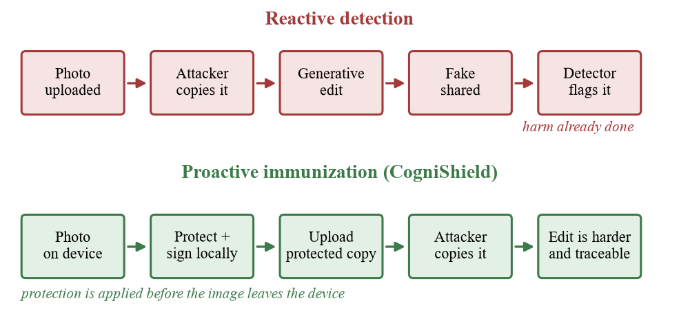
Fig. 1.1 Reactive Detection Versus Proactive Immunization
CogniShield combines the second and third columns of Table 1.1: it immunizes before publication and signs the result. Fig. 1.1 contrasts the reactive timeline of detection with the proactive timeline that this project follows.
1.4 Organization of the Report
The report follows the structure prescribed by the project template. Table 1.2 shows how the chapters relate to the work that was done and where each kind of evidence can be found.
Table 1.2 Organization of the Report
Chapter | Title | Content
1 | Introduction | Objective, motivation and the technical background on generative editing, adversarial perturbations, compression, provenance and quality metrics
2 | Project Description and Goals | Problem statement, scope, threat model, measurable goals, use cases, literature survey and research gap
3 | Technical Specification | Hardware, software, libraries, requirements, architecture, interfaces and data formats
4 | Design Approach and Details | Algorithms with equations, provenance protocol, model test, worked example, standards, constraints and trade-offs
5 | Schedule, Tasks and Milestones | Work breakdown, timeline, milestones and risk register
6 | Project Demonstration | Walkthrough of the interface and demonstrations on real runs
7 | Cost Analysis / Result and Discussion | Experiments on 14 images, analysis, limitations, ethical considerations and cost
8 | Summary | Findings, limitations, recommendations and future work
9 | References | APA-style reference list
A | Appendix A | Sample code, output structure and additional figures

CHAPTER 2
PROJECT DESCRIPTION AND GOALS
This chapter states the problem that CogniShield addresses, fixes the boundaries of what the prototype does and does not attempt, describes the adversary that the design assumes, lists the measurable goals, and places the project among related work. A precise statement of scope and threat model is important in security-oriented projects because protection claims are only meaningful relative to an attacker and a set of assumptions.
2.1 Problem Statement
Generative AI tools can manipulate images before their owners know that an attack has happened. Existing detection systems react after fake content has already been generated or shared, and the owner of the original photograph has no practical means of making the original harder to misuse or of proving later which version of a photograph is the one they released. The problem addressed by this project is therefore stated as follows.
Given a digital image held by its owner, produce a visually near-identical protected copy whose pixel values differ from the original by at most a small, user-controlled bound, that is designed to remain effective after JPEG compression, whose quality cost is measured and reported, and whose exact bytes are cryptographically signed so that later tampering is detectable. The entire process must run locally.
The problem has three coupled requirements that pull against each other. The perturbation must be small enough to be invisible to a human viewer, but strong enough to influence a generative model. It must be robust to the compression that platforms apply, although compression is designed to discard exactly the kind of fine detail in which small perturbations live. And the protected output must be verifiable, which requires that it is stored in a lossless format whose bytes do not change between signing and verification. The design in Chapter 4 resolves these tensions pragmatically and the evaluation in Chapter 7 measures how well each requirement is met.
2.2 Scope of the Project
This version of CogniShield focuses on still images only. It is designed as a review-ready minimum viable product (MVP) rather than a production service. Table 2.1 lists what is inside and outside the scope.
Table 2.1 Scope of the Prototype
In scope | Out of scope
Protecting a single RGB image at a time through the web interface, or a folder of images through the command line | Video, audio, or live camera streams
Seeded, edge-aware, high-frequency perturbation bounded by a per-pixel budget | Gradient-based optimisation against the internals of a specific generative model
JPEG-aware feedback and robustness testing at qualities 95, 85, 75, 60 and 50 | Guarantees against cropping, heavy resizing, denoising, screenshots or print-and-scan
PSNR, SSIM, MSE, mean and maximum absolute delta | Perceptual studies with human participants
SHA-256 and Ed25519 signing and verification of the protected PNG | Public-key infrastructure, certificate authorities or key revocation
Optional side-by-side test with a local SD-Turbo image-to-image pipeline | Evaluation against face-swap, inpainting or text-to-video systems
Windows 10 and 11 with Python 3.12; optional NVIDIA GPU for SD-Turbo | Mobile applications, browser-only execution or cloud deployment

The input formats are PNG, JPEG and WEBP with a size limit of 200 MB, and the protected output is always written as a lossless PNG so that the signed bytes remain unchanged. The optional SD-Turbo module is disabled by default and the rest of the system works without it.
2.3 Threat Model
The threat model follows the proposal that motivated the project. The attacker has access to an image that the defender has uploaded online, and tries to transform it with a generative image-to-image model. The defender protects the image before upload. The first target model for the prototype is local SD-Turbo image-to-image generation. Fig. 2.1 summarises the actors and data flows.
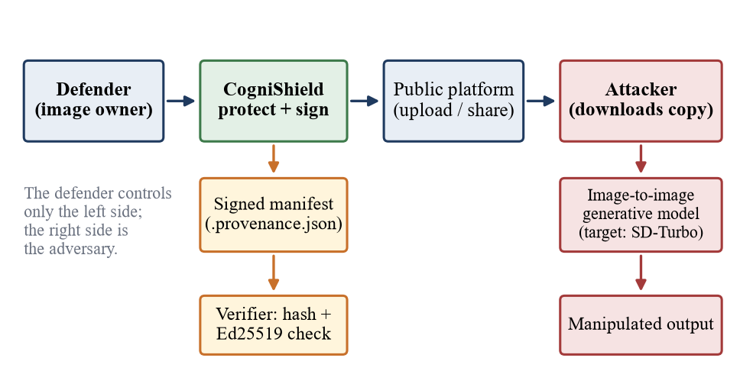
Fig. 2.1 Threat Model and Actors in the CogniShield Scenario
2.3.1 Adversary capabilities
The assumed adversary can download any image that the defender publishes, can run a pretrained image-to-image diffusion model locally with a prompt and a seed of their choosing, and can apply ordinary post-processing such as JPEG compression, which is what most platforms do automatically. The adversary does not know the defender's private signing key and cannot forge a signature over a modified file. The adversary is not assumed to know the defender's seed or budget, although the system does not rely on keeping the perturbation secret.
2.3.2 Defender capabilities and assumptions
The defender controls the original file and the computer on which protection is performed, keeps the private key in the project key folder and distributes the protected PNG and optionally the manifest. The defender is assumed to publish the lossless protected file wherever the platform allows it; when a platform recompresses the image, the JPEG-aware design aims to retain part of the perturbation, and the evaluation quantifies how much.
2.3.3 Security properties claimed and not claimed
The provenance module claims only that the bytes of a protected image match the signed hash and that the signature was produced by the holder of the local private key. It does not claim that a scene is objectively real, that the signer is who they say they are, or that a file was never copied. The perturbation module claims that the protected image differs from the original by a bounded, measured amount and that the effect on SD-Turbo can be inspected. It does not claim immunity against every model, editor or transformation. These distinctions are repeated in the discussion in Chapter 7 because overstated security claims are a common failure of protection tools.
2.3.4 Attack scenarios and expected outcomes
The threat model can be made concrete by listing the scenarios that the design considers. Table 2.2 lists each scenario with the effect that the protection and the provenance mechanism are expected to have and the place in this report where the expectation is tested.
Table 2.2 Attack Scenarios and Expected Outcomes
Scenario | Expected effect of the perturbation | Expected provenance outcome | Section
Direct image-to-image edit of the lossless protected PNG | Perturbation fully present; its effect on the model is measured | Signature valid for the untouched file | 7.9, 7.10
Platform recompresses the upload as JPEG at quality 95 or 75 | About half of the perturbation survives along its own direction | The recompressed copy does not verify; the original PNG still does | 7.5, 7.9
Platform recompresses at quality 50 | Most of the perturbation is removed | The recompressed copy does not verify | 7.5
Rescaling, blurring or median filtering before editing | Most of the perturbation is removed | The altered copy does not verify | 7.6
Screenshot or print-and-scan | Not evaluated; expected to remove most of it | The copy does not verify | Not evaluated
Attacker alters the file and claims it is the original | Not relevant | Digest mismatch is detected | 7.9
Attacker signs an altered file with their own key | Not relevant | Verification with the owner's public key fails | 4.1.11

2.4 Goals and Objectives
The objectives listed in Section 1.1 are turned into measurable goals in Table 2.3. Each goal has an acceptance criterion that is checked in the results chapter.
Table 2.3 Project Goals and Acceptance Criteria
ID | Goal | Acceptance criterion
G1 | Imperceptible protection | PSNR above 30 dB and SSIM close to 1.0 at the default settings on a varied image set
G2 | Bounded change | Maximum absolute pixel change never exceeds the selected budget ε
G3 | Compression awareness | Protected image evaluated at JPEG qualities 95, 75 and 50, with the effect of feedback iterations measured
G4 | Reproducibility | Same image, seed and settings give a bit-identical protected image
G5 | Verifiable provenance | A signature verifies for the untouched file and fails when a single byte is altered
G6 | Target-model comparison | Original and protected images are passed through SD-Turbo with identical prompt and seed and shown side by side
G7 | Usability | A user with no programming knowledge can protect an image in the browser and download the outputs
G8 | Local operation | No image or key leaves the machine; the web server binds to the loopback address only

2.5 System Overview
CogniShield consists of a core library of six small modules, a Flask web application and two command-line programs. Fig. 2.2 shows how the user reaches the library through either interface and where outputs, keys and the optional model are stored. The library modules and their responsibilities are detailed in Chapter 3, and the algorithms inside them are described in Chapter 4.
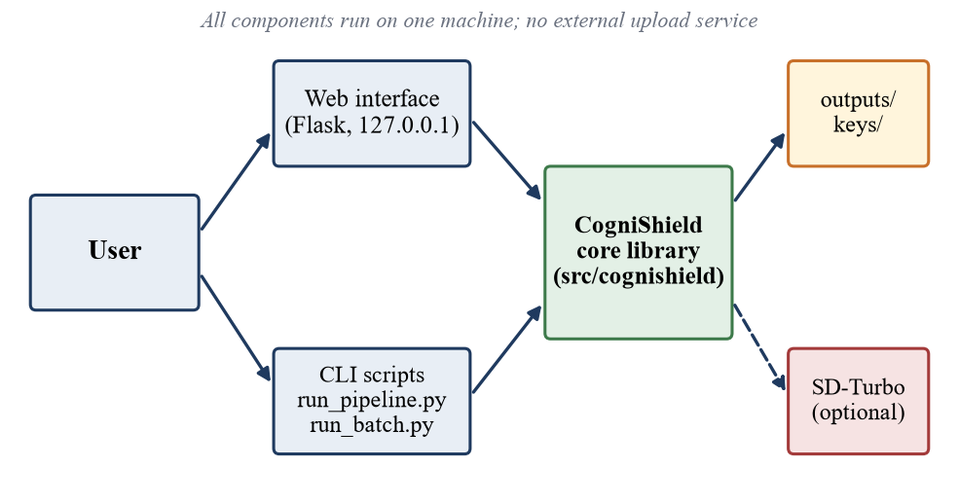
Fig. 2.2 System Context of CogniShield
The user interacts with the system in four steps. First, the user chooses an image and, if desired, adjusts the protection controls. Second, the system generates the protected image and its inspection images. Third, the system measures quality and JPEG robustness and signs the protected output. Fourth, the user downloads the protected PNG and the provenance manifest and may inspect the optional SD-Turbo comparison. All results of a run are written to a run-specific folder so that every experiment can be revisited.
2.6 Literature Survey
The idea of protecting images with small perturbations draws on three research threads: adversarial examples, protection tools aimed at specific misuse scenarios, and content provenance. Table 2.4 summarises the most relevant works and the position of CogniShield among them.
Table 2.4 Related Work and Position of CogniShield
Work | Idea | Difference from CogniShield
Szegedy et al. (2014); Goodfellow et al. (2015) | Small bounded perturbations fool classifiers; fast gradient sign method | Attack on classifiers; CogniShield applies a bounded perturbation as a protective measure
Madry et al. (2018) | Projected gradient descent as a strong first-order attack | Requires gradients of a model; CogniShield is gradient-free in this version
Dziugaite et al. (2016); Shin & Song (2017) | JPEG weakens adversarial perturbations; differentiable JPEG helps survive it | CogniShield uses the real JPEG encoder in a residual feedback loop
Salman et al. (2023) PhotoGuard | Immunizes images against diffusion-based editing by attacking the model | Requires access to the target model and substantial compute; CogniShield is lightweight and local
Shan et al. (2020) Fawkes; Cherepanova et al. (2021) LowKey | Cloak photographs against face-recognition training or matching | Different misuse scenario: recognition rather than generative editing
Shan et al. (2023) Glaze; Liang et al. (2023) AdvDM; Van Le et al. (2023) Anti-DreamBooth | Protect artists and users from style mimicry and personalised fine-tuning | Target training or personalisation; CogniShield targets image-to-image editing and adds signing
C2PA specification | Signed provenance manifests linked to certificate trust | Needs PKI; CogniShield uses a local key pair and a sidecar manifest as a prototype

The common weakness of the protection systems in the table is that they are designed around a particular model and usually need a GPU, and none of them couples the protection step with an integrity proof that the owner can hand to others. CogniShield accepts a weaker, model-agnostic perturbation in exchange for running on an ordinary computer in a fraction of a second per image, and it couples that perturbation to verifiable provenance and a built-in measurement of cost and robustness.
2.7 Research Gap and Contribution
Three gaps motivate the project. First, most immunization methods are evaluated by the authors against specific models, and a student or researcher cannot easily reproduce the pipeline end to end on a laptop. Second, quality metrics, compression robustness and target-model effects are rarely reported together in one tool, so a user cannot judge the trade-off for their own image. Third, protection and provenance are normally treated as separate topics.
The contributions of this project are therefore: a complete, local, reproducible pipeline that links perturbation, measurement and signing; a gradient-free, JPEG-aware feedback mechanism that uses the real encoder; a reporting design that exposes PSNR, SSIM, MSE, absolute deltas and compression results for every run; an optional target-model test isolated in its own process so that failures cannot break the main workflow; and an honest empirical evaluation, presented in Chapter 7, that identifies where the prototype works and where it does not.
2.8 Deliverables
The following deliverables result from the project:
- The CogniShield source code, comprising the core library, the Flask web application, the command-line programs and the PowerShell helper scripts for setup and launch.
- A responsive web interface with dark mode by default and a light-mode toggle, including a How it works page that explains the processing flow.
- Output artefacts for each run: the protected PNG, a noise preview, a difference image magnified twelve times, JPEG variants, the signed provenance manifest and, for command-line runs, a machine-readable report.
- Batch experiment support that writes a summary table in CSV form for any folder of images.
- The optional SD-Turbo comparison module and documentation for downloading the model locally.
- This project report, together with the experimental data and figures generated from the project code.
2.9 Use Cases and Requirement Traceability
Five use cases describe how people use the system. They are listed in Table 2.5. The first two are performed by an ordinary user of the web interface, the third by anyone who holds the protected file, the manifest and the public key, and the last two by a researcher who evaluates the tool.
Table 2.5 Use Cases
ID | Use case | Actor | Main flow | Outcome
UC1 | Protect a single image | User | Choose image, set controls, press Protect, download protected PNG and manifest | Signed protected image
UC2 | Inspect quality and robustness | User | Read metrics, compression table, difference image, noise preview and JPEG previews | Informed choice of settings
UC3 | Verify provenance | User or third party | Recompute the digest of the file, compare with the manifest and verify the signature with the public key | Valid or invalid result with a reason
UC4 | Batch evaluation | Researcher | Place images in the input folder and run the batch program | summary.csv and per-image folders
UC5 | Target-model comparison | Researcher | Enable the SD-Turbo test, enter a prompt, protect an image | Side-by-side model outputs

In the web interface, verification is performed automatically when a protected image is created and its result is displayed in the provenance panel; verifying a file at a later time uses the library function verify_image on the image, the manifest and the public key.
Table 2.6 shows how the goals of Section 2.4 are covered by the functional requirements of Chapter 3 and by the experiments of Chapter 7, so that every goal can be traced to an implementation and to evidence.
Table 2.6 Traceability From Goals to Requirements and Evidence
Goal | Short description | Functional requirements | Evidence
G1 | Imperceptible protection | FR2, FR5, FR6 | Sections 7.2, 7.3
G2 | Bounded change | FR2, FR5 | Section 7.2
G3 | Compression awareness | FR3, FR7, FR8 | Sections 7.4, 7.5, 7.6
G4 | Reproducibility | FR4 | Section 7.8
G5 | Verifiable provenance | FR9, FR10 | Section 7.9
G6 | Target-model comparison | FR11 | Section 7.10
G7 | Usability | FR1, FR12, FR14 | Chapter 6
G8 | Local operation | FR13 and the non-functional requirements | Sections 3.5, 4.3.4

CHAPTER 3
TECHNICAL SPECIFICATION
This chapter specifies the environment in which CogniShield runs, the software on which it depends, the functional and non-functional requirements it satisfies, the architecture of its components and the interfaces through which a user or another program can drive it. The specification is derived from the project's source code, its requirement files and its README, so that the statements below can be checked against the repository.
3.1 Hardware Requirements
The protection pipeline itself uses only CPU operations on arrays and the JPEG encoder from the Pillow library, so it runs on any reasonably modern computer. The optional SD-Turbo comparison is the only component that benefits from a graphics processor. Table 3.1 lists the requirements for the two modes of operation.
Table 3.1 Hardware Requirements
Item | Core protection (required) | SD-Turbo target test (optional)
Processor | Any 64-bit CPU; no vector extensions needed | Same; the GPU performs the model work
Graphics | Not required | NVIDIA GPU with a working CUDA driver
Memory | 4 GB RAM is sufficient for images of several megapixels | Enough GPU memory to load SD-Turbo in half precision
Disk space | About 2 GB for Python packages; about 5 MB per protected run | Several additional GB for the local model weights
Display | Any modern browser at 1280 × 720 or larger | Same
Network | Needed only for the first package installation | Needed once to download the model, then offline

Storage use per run is small. In the 18 web-interface runs that were recorded during development, a run folder holding the original, the protected image, the noise preview, the difference image, three JPEG variants and the manifest occupied about 4.2 MB for an 801 × 775 image and about 10.5 MB for a 941 × 1672 image; a run that also stored two SD-Turbo outputs occupied about 4.9 MB.
3.2 Software Requirements
Table 3.2 summarises the software environment. The project targets Windows 10 and Windows 11 because the helper scripts are written in PowerShell, but the Python code is portable.
Table 3.2 Software Requirements
Component | Specification | Remarks
Operating system | Windows 10 or Windows 11 | PowerShell scripts for setup and launch
Language runtime | Python 3.12 | Installed with winget or from python.org
Environment | Virtual environment in .venv | Created by the setup script
Web browser | Any current browser | Interface served at http://127.0.0.1:5000
GPU stack | PyTorch with CUDA 12.8 wheels | Only for the SD-Turbo test
Model | SD-Turbo in models/sd-turbo/ | Downloaded with the huggingface_hub package

3.3 Libraries and Dependencies
The dependencies are split into three requirement files so that a user who only needs protection and provenance does not have to install the large machine-learning stack. Table 3.3 lists each library and the role it plays.
Table 3.3 Python Libraries and Their Roles
Library | Group | Role in CogniShield
NumPy | Core | Float arrays, random noise generation, vectorised pixel arithmetic and metrics
Pillow | Core | Image loading, PNG and JPEG encoding, Gaussian blur, resizing
scikit-image | Core | Structural similarity index (SSIM) computation
cryptography | Core | Ed25519 key generation, signing and verification; PEM serialisation
Flask | Core | Local web server, routing, upload handling and JSON responses
OpenCV and pandas | Core | Listed for image analysis and tabulation of batch results
torch and torchvision | AI | Tensor runtime and CUDA support for SD-Turbo
diffusers and transformers | AI | Image-to-image pipeline and text encoder for SD-Turbo
accelerate, safetensors | AI | Efficient model loading and weight format
huggingface_hub and hf_xet | AI | Local download of the SD-Turbo model snapshot
matplotlib | AI | Plotting support for analysis

Python's standard library supplies hashlib for SHA-256, json for manifests, base64 for signature encoding, multiprocessing for the isolated SD-Turbo worker, and dataclasses for the configuration objects.
3.4 Functional Requirements
Table 3.4 lists the functional requirements. Each requirement is traceable to a module in the source code, which is shown in the last column.
Table 3.4 Functional Requirements
ID | Requirement | Module
FR1 | Accept PNG, JPG, JPEG and WEBP images up to 200 MB and convert them to RGB | app.py, image_io
FR2 | Allow the user to set the perturbation budget from 1 to 16 out of 255 | app.py, protector
FR3 | Allow the user to set the number of compression-feedback iterations from 0 to 8 | app.py, protector
FR4 | Allow the user to set an integer seed from 0 to 999999 for reproducible noise | app.py, protector
FR5 | Generate a protected image, a noise preview and a ×12 difference image | protector, metrics
FR6 | Compute PSNR, SSIM, MSE, mean absolute delta and maximum absolute delta | metrics
FR7 | Evaluate the protected image after JPEG compression at selected qualities from 95, 85, 75, 60, 50 | compression
FR8 | Save the protected image as PNG and JPEG variants for inspection | compression, app.py
FR9 | Sign the protected PNG with Ed25519 over its SHA-256 digest and write a JSON manifest | provenance
FR10 | Verify the signature and report whether the image changed after signing | provenance
FR11 | Optionally run original and protected images through SD-Turbo with identical prompt and seed | sd_turbo, app.py
FR12 | Provide downloads of the protected image and the manifest | app.py
FR13 | Process a single image or a folder from the command line and write a report or CSV summary | run_pipeline.py, run_batch.py
FR14 | Present a dark-mode default interface with a light-mode toggle and a How it works page | templates, static

3.5 Non-Functional Requirements
Table 3.5 Non-Functional Requirements
Attribute | Requirement | How it is met
Privacy | No image or key is sent to an external service | Server bound to 127.0.0.1; processing and storage are local
Reproducibility | Identical inputs and settings give identical outputs | Seeded generator; deterministic array operations
Performance | A typical image is protected in well under a second on a CPU | Vectorised NumPy operations and a few JPEG round trips
Robustness of the service | An optional-model failure must not lose the protection result | SD-Turbo runs in a separate process with a 300 s timeout
Input safety | Reject unreadable or unsupported files with a clear message | Extension check, image decoding in a try block, secure_filename
Parameter safety | Out-of-range parameters must not crash the server | Integer parsing with clamping to documented ranges
Maintainability | Small modules with a single responsibility | Six library modules, each below about 125 lines
Usability | Single-page workflow with drag and drop and clear status messages | Responsive HTML, CSS and JavaScript interface
Portability | Core features run without a GPU | Optional AI dependencies kept in a separate requirements file

3.6 System Architecture
3.6.1 Layered view
CogniShield follows a layered structure, shown in Fig. 3.1. The presentation layer consists of the HTML templates, the stylesheet, the JavaScript and the command line. The application layer holds the Flask application and the two command-line programs, which contain no image-processing logic of their own. The domain layer is the cognishield package, which implements protection, compression testing, metrics, provenance and the optional model runner. Below it are the scientific and cryptographic libraries, the optional machine-learning runtime and the operating platform.
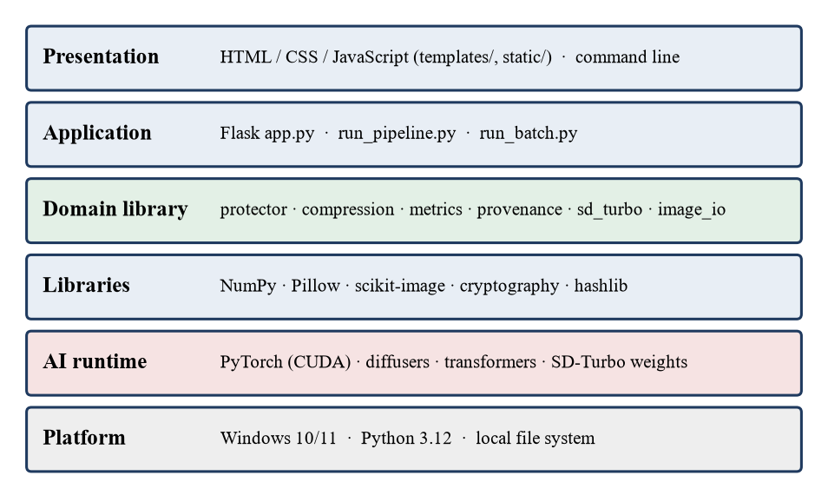
Fig. 3.1 Layered Software Stack of CogniShield
3.6.2 Module structure
The domain layer contains six modules and a configuration file, shown in Fig. 3.2 and described in Table 3.6. The modules are deliberately small and communicate through plain function calls and immutable dataclasses, which keeps the data flow easy to inspect and test.
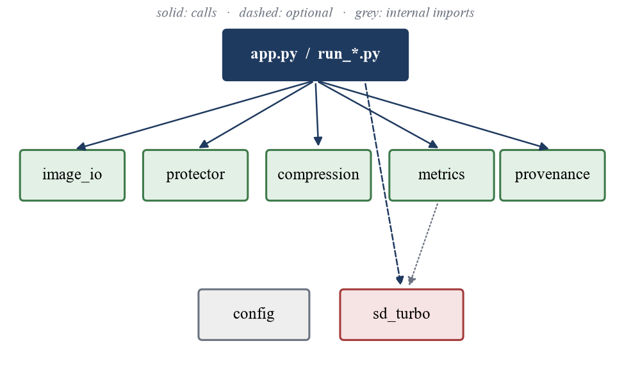
Fig. 3.2 Module Structure of the CogniShield Library
Table 3.6 Responsibilities of the Library Modules
Module | Lines | Responsibility
config.py | 14 | Project root, model folder, output folder, key folder and data folder paths; creation of required folders
image_io.py | 30 | Loading as RGB, conversion between PIL images and float arrays in [0, 1], resizing to multiples of eight for the model
protector.py | 84 | The protection configuration and the algorithm: high-frequency noise, edge mask, bounded perturbation and JPEG feedback
compression.py | 36 | JPEG round trip, saving JPEG variants and evaluating the protected image after compression
metrics.py | 60 | PSNR, SSIM, MSE, mean and maximum absolute delta, and the amplified difference image
provenance.py | 121 | SHA-256 hashing, Ed25519 key management, signing, manifest writing and verification
sd_turbo.py | 84 | Lazy loading of the SD-Turbo image-to-image pipeline and a seeded run method

3.6.3 Request flow in the web application
Fig. 3.3 shows the sequence of calls that the web application performs for one request. The browser posts the image and settings to the protection endpoint. The server validates them, calls the protector, then the metric and compression functions, then the provenance functions, and returns a single JSON document that the page renders into the result panels.
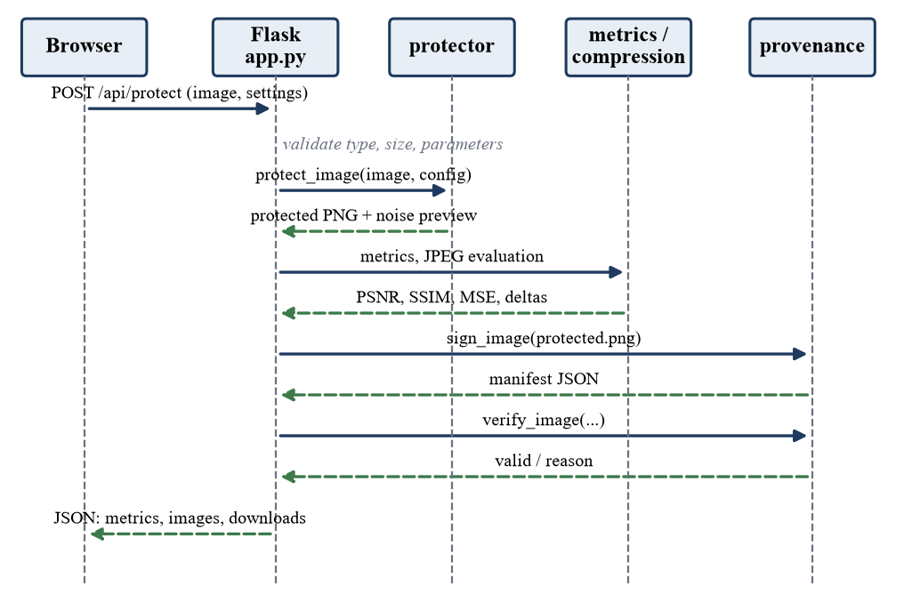
Fig. 3.3 Sequence of Calls for a Protection Request
3.7 Interface Specification
3.7.1 Web endpoints
Table 3.7 lists the HTTP endpoints exposed by the Flask application.
Table 3.7 HTTP Endpoints of the Web Application
Method | Path | Purpose
GET | / | Main workspace page
GET | /how-it-works | Same-tab guide that explains the processing flow
POST | /api/protect | Accepts the image and form fields; returns JSON with images, downloads, metrics, compression table, JPEG images, provenance result and optional model result or error
GET | /results/<run_id>/<file> | Serves a result image from the run folder for display
GET | /download/<run_id>/<file> | Serves the protected PNG or the manifest as an attachment

The form fields accepted by the protection endpoint are image, epsilon, iterations, seed, qualities (repeated), run_model and prompt. Errors are returned as JSON with an explanatory message: HTTP 400 for a missing, unsupported or unreadable file, HTTP 413 when the 200 MB limit is exceeded and HTTP 500 for an unexpected failure during protection.
3.7.2 Control reference
Table 3.8 Protection Controls and Their Effects
Control | What it changes | Default | Practical guidance
Perturbation budget | Maximum allowed pixel change, from 1 to 16 out of 255 | 8 | Higher is stronger but can be more visible
Compression feedback | Number of JPEG-aware refinement steps, 0 to 8 | 4 | Higher may improve JPEG resilience but takes longer and adds energy
Seed | Random starting point of the noise field | 42 | Keep fixed for repeatable results
JPEG tests | Qualities to evaluate: 95, 85, 75, 60, 50 | 95, 75, 50 | Choose qualities that match the sharing path
Run SD-Turbo target test | Runs both versions through the local model | Off | Enable only after model setup
Target prompt | Prompt used by the optional test | Portrait prompt | Use the same prompt for a fair comparison

3.7.3 Command-line programs
The two command-line programs share the library with the web application. Table 3.9 lists their options.
Table 3.9 Command-Line Programs and Options
Program | Option | Default | Meaning
run_pipeline.py | image (positional) | none | Path of the input image
run_pipeline.py | --epsilon | 8/255 ≈ 0.03137 | Maximum perturbation on a 0–1 scale
run_pipeline.py | --seed, --iterations | 42, 4 | Seed and number of feedback iterations
run_pipeline.py | --qualities | 95 75 50 | JPEG qualities for testing; only values of 50 and above feed back into the perturbation
run_batch.py | --input-dir | data/input | Folder searched recursively for PNG, JPG, JPEG and WEBP files
run_batch.py | --epsilon, --seed, --iterations, --qualities | as above | Same meaning as for a single image

3.8 Data Specification
3.8.1 Folder layout
The repository separates source code, generated outputs, keys, models and data, as shown in Table 3.10. Generated outputs, keys and models are excluded from version control by the project's ignore file, which prevents private keys from being committed accidentally.
Table 3.10 Folder Layout of the Project
Path | Contents
app.py, run_pipeline.py, run_batch.py | Entry points
src/cognishield/ | The six library modules and the configuration
templates/, static/ | HTML pages, stylesheet and JavaScript for the web interface
scripts/ | PowerShell helpers: setup, run_app, run_cli_example, run_batch
docs/ | Report outline and documentation
data/input/, data/samples/ | Images to be processed; placeholders are kept in version control
outputs/web/<run id>/ | Result files of each web run, named by a 12-character hexadecimal identifier
outputs/<image name>/, outputs/batch/ | Result files of command-line and batch runs, and summary.csv
keys/ | Ed25519 private and public keys in PEM format
models/sd-turbo/ | Local SD-Turbo model snapshot

3.8.2 Output files of a run
Every run writes the original image, the protected PNG, the noise preview, the difference image magnified twelve times and one JPEG file for each selected quality. The signed manifest is stored next to the protected image with the suffix .provenance.json. When the optional model test runs, two further images are written, one for the original and one for the protected input.
3.8.3 Provenance manifest
The manifest is a JSON document with the fields in Table 3.11.
Table 3.11 Fields of the Provenance Manifest
Field | Meaning
project | Constant string "CogniShield"
algorithm | "Ed25519 over SHA-256(image_bytes)"
image_file | File name of the signed image
image_hash_sha256 | Hexadecimal SHA-256 digest of the image file bytes
signature_base64 | Ed25519 signature of the 32-byte digest, base64 encoded (64 bytes before encoding)
public_key_file | Name of the public key file used for verification
signed_at_utc | ISO 8601 timestamp with time zone
metadata | Source file name, epsilon (fraction and pixels), iterations, seed and JPEG qualities

3.9 Environment Setup
Setup is automated for Windows. The setup.ps1 script creates a virtual environment in .venv, upgrades pip and installs the core, CUDA PyTorch and AI requirement files in that order. Users who only need protection, metrics, JPEG testing and provenance can install the core requirements alone. The server is started with the run_app.ps1 script or directly with the virtual environment's Python interpreter running app.py, and it is stopped with Ctrl + C in the terminal. The PowerShell execution policy can be relaxed for the current window only, so no permanent system setting is changed. Appendix A reproduces the main commands.
3.10 Output Tree of a Run
The listing below shows the files in the run folder of the web run that included the optional model test. The same names are used in every run; the two sd_turbo files are only present when the model test was requested, and a command-line run stores its files in a folder named after the input image instead.
outputs/web/0684920cc8de/
original.png uploaded image converted to RGB
protected.png protected image (the signed file)
protected.png.provenance.json signed manifest
protected_jpeg_q95.jpg protected image re-encoded at quality 95
protected_jpeg_q75.jpg protected image re-encoded at quality 75
protected_jpeg_q50.jpg protected image re-encoded at quality 50
noise_preview.png perturbation magnitude as a fraction of the budget
difference_x12.png absolute difference multiplied by twelve
sd_turbo_original.png model output for the original (optional)
sd_turbo_protected.png model output for the protected image (optional)
3.11 Assumptions and Dependencies
The specification rests on a small number of assumptions that should be checked before the system is used or extended.
- Python 3.12 and the packages listed in the requirement files are available; the code uses type-hint syntax that requires a recent Python version.
- The user owns the images or is authorised to process them, and publishes the lossless protected file wherever the platform allows it.
- The loopback address and port 5000 are free on the machine; if another process uses the port, it must be stopped first.
- The SD-Turbo model, if used, has been downloaded to the model folder, the driver and the CUDA build of PyTorch are compatible, and the GPU has enough free memory.
- The key folder is writable on the first run so that the key pair can be created, and the private key is kept private.
- Results are interpreted as measurements of similarity and robustness, and not as proof that an image is authentic or safe.
CHAPTER 4
DESIGN APPROACH AND DETAILS
This chapter explains how CogniShield is designed and how each stage of the pipeline works. It begins with the design approach and the algorithms, continues with the codes and standards that the implementation follows, and ends with the constraints, alternatives and trade-offs that shaped the design. The mathematical definitions given here correspond line by line to the implementation in the cognishield package.
4.1 Design Approach / Materials & Methods
4.1.1 Design principles
Five principles guided the design. The first is locality: all computation, storage and key handling happen on the user's own computer. The second is transparency: every stage produces an artefact or a number that can be inspected, such as the noise preview, the magnified difference image and the metric table. The third is boundedness: the maximum change to any pixel is limited by a single, user-visible parameter that is enforced by clipping, not merely hoped for. The fourth is isolation of risk: the heavy and failure-prone SD-Turbo test runs in a separate process so that it can never destroy a protection result. The fifth is modesty of claims: the system reports measurements and shows model outputs instead of declaring an image immune.
4.1.2 Overall pipeline
The complete processing sequence is shown in Fig. 4.1. An input image is converted to an RGB floating-point array, a seeded high-frequency noise field and an edge mask are created, their product is limited to the perturbation budget, and the result is refined by a JPEG feedback loop. The protected PNG, a noise preview and a magnified difference image are then produced, quality and robustness are measured, and the protected file is hashed, signed and verified.
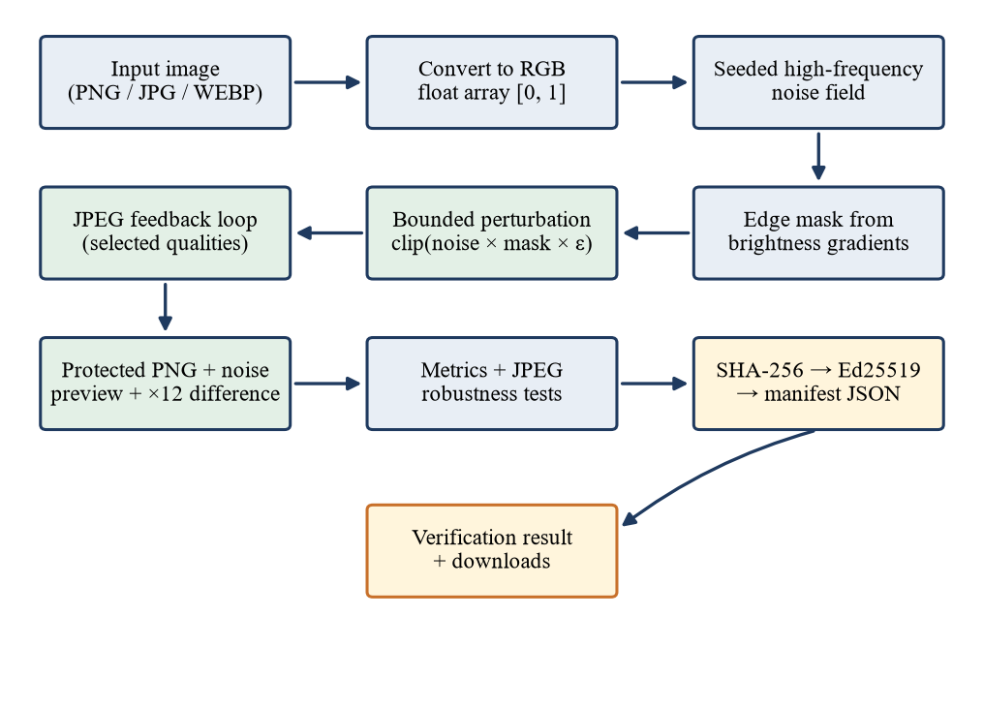
Fig. 4.1 End-to-End Processing Pipeline of CogniShield
4.1.3 Image representation
All computation uses single-precision floating point arrays with values in the range 0 to 1. The function load_rgb_image opens a file with Pillow and converts it to three-channel RGB, so grayscale images, palette images and images with an alpha channel all enter the pipeline in the same form. pil_to_float_array divides the 8-bit values by 255, and float_array_to_pil clips to the valid range, multiplies by 255, rounds and converts back to 8 bits. The rounding to 8 bits at the very end means that the final integer perturbation can differ from the floating-point perturbation by up to half a level; the measured maximum absolute difference in Chapter 7 is exactly the budget in 8-bit levels.
4.1.4 High-frequency noise generation
The protective signal is built from random noise because noise has no semantic content that an editing model could latch onto, and it is made high-frequency because the human eye is least sensitive to fine, rapidly varying patterns. The generator _high_frequency_noise draws a standard normal array of the same shape as the image from a NumPy generator initialised with the user's seed. It then forms a smoothed copy by rescaling the array to 8 bits, applying a Gaussian blur of radius 1.2 pixels with Pillow and rescaling the result to the range minus one to one. Subtracting the smoothed copy from the raw noise removes the low-frequency part, and dividing by the largest absolute value normalises the result to the range minus one to one. The operation can be written as in Eqn. 4.1, where ξ is the raw noise and G_{σ} denotes Gaussian smoothing.
$n=\frac{h}{max|h|}, h=ξ-G_{σ}(ξ)$ (4.1)
Because the generator is seeded, the same seed always yields the same noise for a given image shape, which makes every run reproducible. Different seeds give different noise patterns, and Section 7.8 measures how much the visual quality varies between seeds.
4.1.5 Edge mask
A uniform noise field would be most visible in smooth regions such as sky or skin, where the eye can detect small irregularities, and least visible near edges and textures, where natural variation already masks it. The function _edge_mask therefore estimates local detail from brightness gradients. It converts the image to a single channel by averaging the colour channels, computes the absolute difference between each pixel and its upper neighbour and between each pixel and its left neighbour, and adds the two. The sum is divided by its maximum so that it lies between zero and one. The mask is then compressed into the range 1 − w to 1 with the edge weight w, whose default is 0.65, so that flat regions still receive at least 35 percent of the permitted budget, as in Eqn. 4.2.
$g(i,j)=|I(i,j)-I(i-1,j)|+|I(i,j)-I(i,j-1)|, m=(1-w)+w·\frac{g}{max g}$ (4.2)
The mask is expanded to three channels and multiplied with the noise. Choosing a floor of 35 percent rather than zero keeps the perturbation present in smooth areas as well, which matters because a model that is sensitive to the protected image may be influenced by the global pattern and not only by edges.
4.1.6 Bounded initial perturbation
The initial perturbation is the product of the noise and the mask scaled by the budget, followed by a clip that enforces the bound, as in Eqn. 4.3. Since the normalised noise lies between minus one and one and the mask between 0.35 and 1, the unclipped product already lies within the budget, and the clip is a guarantee rather than a correction. The budget ε is specified in the interface as an integer E between 1 and 16 out of 255 intensity levels, so that ε is E/255, as in Eqn. 4.4. The default value is 8, that is, about 3.1 percent of the full intensity range.
$δ_{0}=clip\left(n⊙m·ε,-ε,+ε\right)$ (4.3)
$δ_{i}∈[-ε, +ε], ε=\frac{E}{255}$ (4.4)
4.1.7 JPEG-aware feedback loop
The perturbation described so far lives in the high-frequency part of the image, which is the part that JPEG discards first. To make the protected image keep as much of the perturbation as possible after compression, CogniShield uses a feedback loop based on the real JPEG encoder. At iteration k the candidate image is formed by adding the current perturbation to the original and clipping, as in Eqn. 4.5. The candidate is compressed and decoded at every quality in a set Q, and the residual that compression removed is averaged over the qualities, as in Eqn. 4.6, where J_{q} denotes a JPEG round trip at quality q.
$x_{k}=clip\left(x+δ_{k},0,1\right)$ (4.5)
$f_{k}=\frac{1}{|Q|}\sum_{q∈Q}{\left(x_{k}-J_{q}\left(x_{k}\right)\right)}$ (4.6)
The perturbation is then updated by adding the residual scaled by a compression weight λ and clipping to the budget, as in Eqn. 4.7. The default weight is 0.16 and the default number of iterations N is 4. Intuitively, the residual is the part of the candidate that compression threw away, so adding a fraction of it to the perturbation pre-compensates for the loss: the components that JPEG would have removed are strengthened for the next round, while the clip prevents the perturbation from ever exceeding the budget.
$δ_{k+1}=clip\left(δ_{k}+λf_{k},-ε,+ε\right)$ (4.7)
After N iterations the protected image is obtained by adding the final perturbation to the original and clipping to the valid range, as in Eqn. 4.8. Setting N to zero disables the loop and yields the initial perturbation only. The complete procedure is shown as a flowchart in Fig. 4.2.
$x_{p}=clip\left(x+δ_{N},0,1\right)$ (4.8)
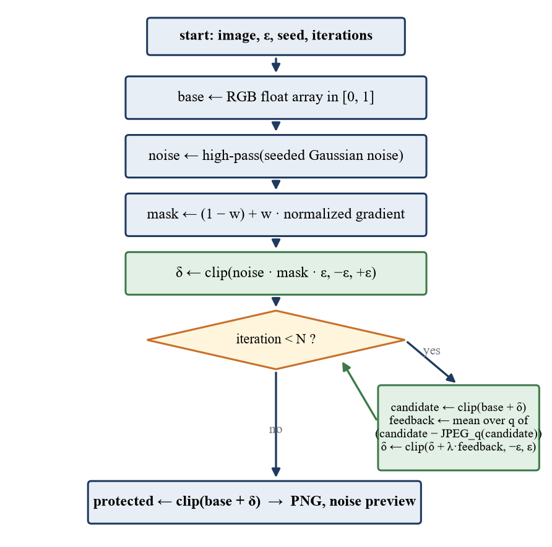
Fig. 4.2 Flowchart of the Protection Algorithm with JPEG Feedback
The feedback loop is gradient-free: it does not differentiate through JPEG, it only calls the encoder. This keeps the code short and independent of any machine-learning framework. Its cost is a few JPEG encodings per iteration, and Chapter 7 shows that the whole algorithm completes in a fraction of a second for typical images. A property that is easy to overlook is that each iteration adds a scaled residual to the perturbation, so the loop tends to raise the average magnitude of the perturbation even though the clip bounds its maximum. This is why the measured PSNR falls as iterations increase; the trade-off is quantified in Section 7.4.
The two terms of the final perturbation differ greatly in size. Because the noise is normalised by its single largest absolute value, typical initial pixel changes are a fraction of a level, about 0.49 levels on average over the 14 test images, whereas the final perturbation averages 1.62 levels. Most of the difference is contributed by the feedback term, which reflects the image's own JPEG residual and therefore depends on the image content as well as on the seed; Section 4.1.19 illustrates this on a small patch and Section 7.4.1 measures it over the whole test set.
4.1.8 Inspection outputs
Besides the protected image, the protector returns a noise preview in which each pixel shows the magnitude of the perturbation as a fraction of the budget, scaled to the range 0 to 255. The metrics module separately produces a difference image, which is the absolute difference between the protected and original images multiplied by a gain of 12 and clipped. Both images are meant for human inspection: at the default budget the true difference is nearly invisible, and the amplified view shows where the perturbation was placed and that it follows the structure of the image.
4.1.9 Quality metrics
Four numerical measures and one structural measure are reported for every comparison of two images x and y with H rows, W columns and three channels and pixel values in [0, 1]. The mean squared error is the average squared pixel difference in Eqn. 4.9. The peak signal-to-noise ratio expresses it on a logarithmic decibel scale relative to the peak value, which is 1 for normalised pixels, as in Eqn. 4.10; if the images are identical the MSE is zero and the ratio is infinite. The structural similarity index of Wang et al. (2004) compares local means μ, variances σ² and covariance σ_{xy} with small stabilising constants C₁ and C₂, as in Eqn. 4.11. The implementation calls the scikit-image function with the colour channel axis specified and a data range of 1.0, and falls back to reporting no SSIM if the library is unavailable. The mean absolute delta and the maximum absolute delta are the mean and maximum of the absolute pixel differences over all pixels and channels.
$MSE=\frac{1}{3HW}\sum_{i=1}^{3HW}{{\left(x_{i}-y_{i}\right)}^{2}}$ (4.9)
$PSNR=10\log_{10}\left(\frac{{MAX}^{2}}{MSE}\right)=20\log_{10}\left(\frac{1}{\sqrt{MSE}}\right)$ (4.10)
$SSIM(x,y)=\frac{\left(2μ_{x}μ_{y}+C_{1}\right)\left(2σ_{xy}+C_{2}\right)}{\left({μ_{x}}^{2}+{μ_{y}}^{2}+C_{1}\right)\left({σ_{x}}^{2}+{σ_{y}}^{2}+C_{2}\right)}$ (4.11)
Table 4.1 Quality Measures Reported by CogniShield
Measure | Desired direction | Interpretation
PSNR | Higher | Pixel-level similarity; values above 30 dB often indicate low visible distortion
SSIM | Closer to 1.0 | Structural similarity between the original and protected images
MSE | Lower | Mean squared pixel error on the 0–1 scale
Mean absolute delta | Lower | Average absolute per-pixel change
Max absolute delta | Lower | Largest absolute change at any pixel and channel; equals the budget in the default pipeline

These measures describe similarity, not whether an image is objectively real, safe or immune. In particular, a high PSNR does not prove that a human would find the image unchanged, and a low PSNR does not prove that a model would be affected.
4.1.10 Compression robustness testing
The compression module performs a JPEG round trip by encoding the image to an in-memory buffer at the requested quality with Pillow's optimising encoder and decoding it again. For each selected quality the evaluation compresses the protected image and compares the result with the original, so the reported PSNR and SSIM include both the cost of the perturbation and the damage caused by compression itself. The same function writes the JPEG files that the interface shows for visual inspection. The web interface offers qualities 95, 85, 75, 60 and 50 and selects 95, 75 and 50 by default, and the command-line programs default to 95, 75 and 50. In the single-image command-line program only qualities of 50 or more are passed to the feedback loop, which keeps the loop to moderate compression levels, while all requested qualities are still used for evaluation.
The JPEG transform that drives these results maps each 8 × 8 block f_{x,y} to frequency coefficients F_{u,v} through the discrete cosine transform in Eqn. 4.12, in which C_{u} and C_{v} equal 1/√2 for index zero and 1 otherwise. The coefficients are divided by entries of a quantisation table scaled by the quality factor and rounded, so high-frequency coefficients of small magnitude are driven to zero. Since the protective perturbation has a magnitude of a few levels, many of its coefficients fall below the quantisation step at low quality, which explains the retention results of Chapter 7.
$F_{u,v}=\frac{1}{4}C_{u}C_{v}\sum_{x=0}^{7}{\sum_{y=0}^{7}{f_{x,y}cos\frac{(2x+1)uπ}{16}cos\frac{(2y+1)vπ}{16}}}$ (4.12)
4.1.11 Cryptographic provenance
The provenance module implements the sign-and-verify protocol in Fig. 4.3. To sign a protected PNG it computes the SHA-256 digest of the file bytes by reading the file in one-megabyte chunks, loads the Ed25519 private key from the key folder (generating a new key pair on first use and saving both keys in PEM format), signs the 32-byte digest and writes a JSON manifest next to the image. The relationship is summarised in Eqn. 4.13, where B denotes the file bytes, h the digest and σ the signature.
$h=SHA-256(B), σ={Sign}_{sk}(h), ok={Verify}_{pk}(σ,h)$ (4.13)
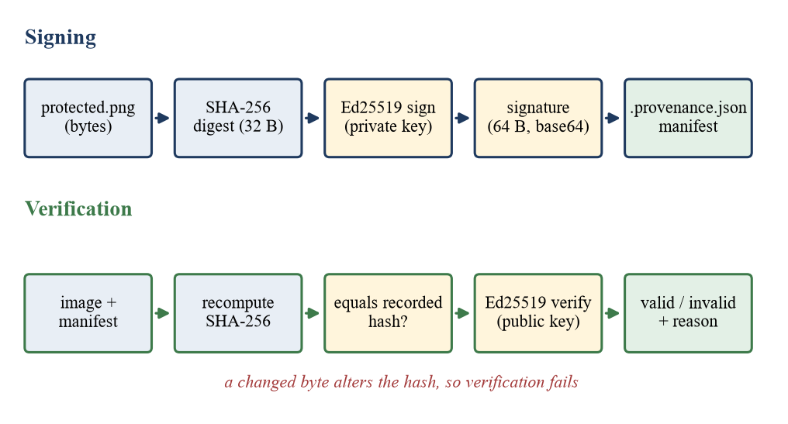
Fig. 4.3 Signing and Verification Protocol of the Provenance Module
Verification recomputes the digest of the file, compares it with the digest recorded in the manifest and then verifies the signature with the public key. The function returns a structured result that states whether verification succeeded, a human-readable reason and the current digest. The possible reasons are that the image file or manifest or public key does not exist, that the image hash changed after signing, that the signature does not match the public key, or that the signature and hash are valid. Hash comparison comes first so that the most common failure, a modified file, is reported with an informative message. Ed25519 signing is deterministic, so the same digest and key always produce the same signature, and the 64-byte signature is stored in base64.
Two design decisions are worth noting. First, the signature is computed over the digest of the protected PNG bytes, not over pixel values, so metadata changes are also detected, which is desirable for integrity but means that any re-encoding invalidates the signature; the manifest therefore applies to the exact file that was saved. Second, the private key is stored unencrypted in a local folder, which is acceptable for a prototype running on the user's own machine but would require protection in a deployed system. The project's ignore file excludes the key folder from version control.
4.1.12 Optional SD-Turbo target test
To observe the effect of protection on a real generative model, the SD-Turbo module loads an image-to-image pipeline from the local model folder with local files only, uses half precision on a CUDA device and single precision otherwise, and enables attention slicing when available. The method that runs the model resizes the image so that its longer side is at most 512 pixels and both sides are multiples of eight, because the model's autoencoder downsamples by a factor of eight. It calls the pipeline with the user's prompt, a guidance scale of zero, a strength of 0.55 and a seeded generator. The number of denoising steps is chosen as the largest of two, the requested steps and the reciprocal of the strength rounded up, so that at least one denoising step remains after the strength is applied; with the default strength this is two steps.
The web application runs this test in a separate operating-system process, shown in Fig. 4.4. The parent process starts a worker, waits for at most 300 seconds, terminates the worker if it has not finished and reads the outcome from a queue. If the model directory is missing, the worker times out or exits abnormally, the page receives an explanatory message and the protection result, which was already computed and signed, is still returned. This isolation was adopted because errors in CUDA or in model loading can terminate a Python process without raising an exception that the web server could catch.
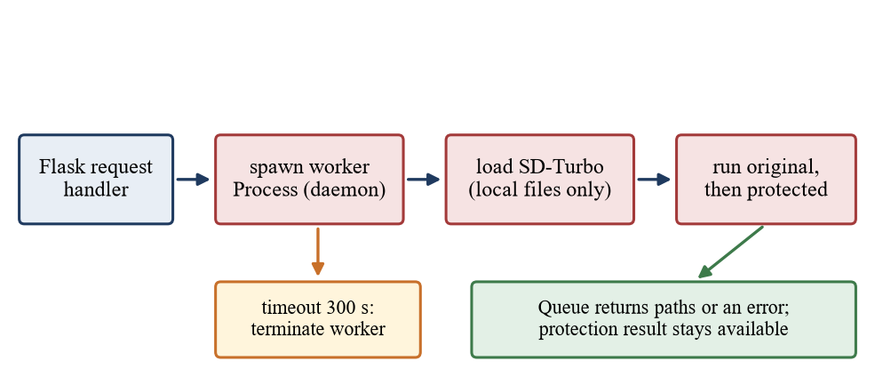
Fig. 4.4 Process Isolation of the Optional SD-Turbo Test
The original and protected images are passed through the same prompt, seed and settings so that any difference between the two outputs is attributable to the protection. Both outputs are saved in the run folder and displayed side by side in the interface. The test does not alter the protected PNG or its signature.
4.1.13 Web application
The web application is a single Flask module. On a protection request it validates the file extension against the allowed set, clamps the numeric parameters to their ranges, reads the uploaded stream with Pillow and rejects unreadable files with a clear message. It then creates a run folder named by a random 12-character hexadecimal identifier, runs the protection, saves the images, signs and verifies the output, writes the JPEG variants and, if requested, runs the model test. Everything is returned in one JSON response. The file names inside the run folder are fixed, which, together with the use of a sanitised version of the uploaded name in the manifest, keeps user-provided strings out of file system paths.
The browser interface is a single page with a settings sidebar, an upload panel and a results panel, shown schematically in Chapter 6. It uses drag and drop, range sliders for the budget and the number of iterations, a seed control with step buttons, checkboxes for the JPEG qualities and an optional prompt field that appears when the model test is enabled. The interface starts in dark mode, offers a light-mode toggle whose choice is remembered in the browser, and links to a How it works page. The JavaScript calls the protection endpoint with the Fetch API, disables the button while processing, shows a status chip, and renders metrics, the compression table, inspection images, the provenance status and the optional model comparison from the returned JSON.
4.1.14 Command-line and batch tools
The single-image program run_pipeline.py loads an image, builds a protection configuration from its arguments, writes the protected image, noise preview, difference image and JPEG variants to a folder named after the input file, computes metrics and compression results, signs and verifies the output and writes a machine-readable report.json that is also printed. The batch program run_batch.py applies the same configuration to every image found recursively in a folder and writes one row per image to outputs/batch/summary.csv with the image size, the five metrics and the PSNR and SSIM at each tested JPEG quality. The batch program was designed to satisfy the review suggestion of running 10 to 20 permitted images, and the experiments of Chapter 7 use the same library calls.
4.1.15 Data flow
Fig. 4.5 presents the system as a level-one data flow diagram with four processes and three data stores. The upload and validation process receives the image and settings from the user; the protection process produces the protected image; the measurement process computes metrics and compression results; and the signing process produces and checks the manifest. Results are written to the run folder, keys are read from and written to the key store, and the optional model reads from the model folder.
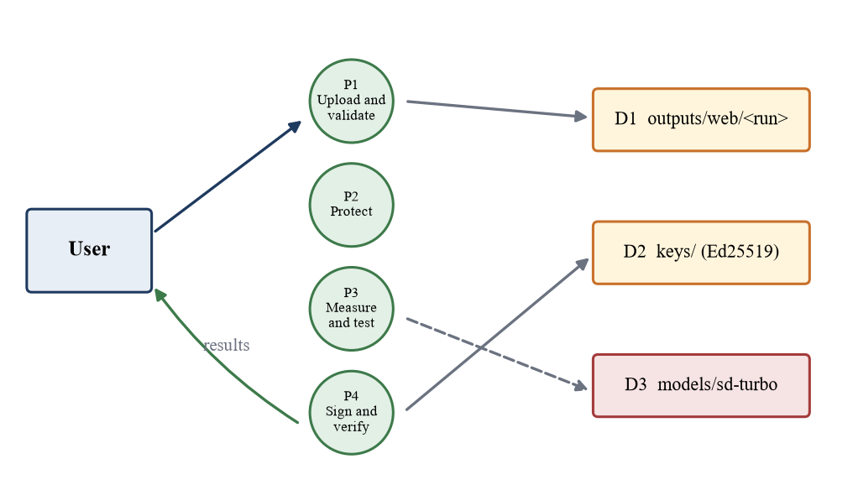
Fig. 4.5 Level-One Data Flow Diagram of CogniShield
4.1.16 Computational complexity
For an image with n = H × W pixels, noise generation, masking and clipping are linear in n. The edge mask and the Gaussian blur are also linear. Each feedback iteration encodes and decodes the candidate once per quality in Q, and the JPEG codec is linear in n, so the protection cost is of the order of n(1 + N|Q|) elementary operations, ignoring constants. Metric computation adds a linear term, with SSIM being the most expensive because of its sliding window. The measured running times in Section 7.11 confirm approximately linear growth of the protection time with the number of pixels. Memory use is a small multiple of the image size, since a handful of float arrays of the same shape are alive at once.
4.1.17 Handling of input edge cases
Because every image is converted to three-channel RGB on loading, a range of input types are handled by one code path. Grayscale images are replicated into three identical channels, palette images are expanded, and images with an alpha channel lose that channel in the conversion, so transparency is not preserved in the protected output. Images are processed at their native resolution, with no resizing, so the protected PNG has exactly the dimensions of the input; only the optional model test resizes, and only its own copy of the image. The loader does not apply the EXIF orientation flag, so a photograph that is stored rotated and displayed rotated by a viewer is protected as stored; since the perturbation is applied pixel by pixel and the protected PNG carries no orientation flag, the protected image appears as the stored pixels, which may differ in orientation from what the user saw in a photo viewer. A user who needs the visible orientation preserved should rotate the image before protecting it. Animated WEBP files are reduced to their first frame by the decoder. These behaviours follow directly from the loading code and are noted here because they affect how the tool should be used.
4.1.18 Numerical precision and determinism
All arithmetic uses 32-bit floating point numbers. The noise is generated by the NumPy default generator, whose output for a given seed is specified by the library version, and all subsequent operations are element-wise array arithmetic, clipping and calls to the JPEG codec of the installed Pillow library. As a consequence, the same image, seed and settings produce the same protected image on the same software stack, which the experiments of Chapter 7 confirm. Across different versions of NumPy, Pillow or the underlying libjpeg implementation the outputs may differ in the last intensity level, because rounding and codec details are not guaranteed to be identical; the provenance manifest therefore records the settings but not the library versions, and the signature protects the saved bytes, not the process that created them. The conversion of the final floating-point array to 8-bit integers rounds to the nearest level, which means that the realised perturbation is an integer number of levels at every pixel, as seen in Table 4.2.
4.1.19 Worked example on a small patch
To make the algorithm concrete, Table 4.2 traces one 4 × 4 patch of the colour portrait of Chapter 7 through the pipeline at the default settings. The patch was chosen automatically as the mid-intensity region with the most varied gradient, and the red channel is shown. The columns list the grey level of each pixel, the normalised gradient, the resulting mask value, the normalised noise sample, the initial perturbation in 8-bit levels and the final perturbation measured from the protected image.
Table 4.2 Worked Example on a 4 × 4 Patch of the Colour Portrait (Red Channel, Default Settings)
Pixel (row, col) | Grey (0–255) | Norm. gradient | Mask m | Noise n | Initial δ (levels) | Final δ (levels)
(468, 230) | 73.3 | 0.052 | 0.384 | +0.006 | +0.02 | +5.00
(468, 231) | 90.0 | 0.059 | 0.389 | +0.398 | +1.24 | +8.00
(468, 232) | 88.7 | 0.053 | 0.384 | +0.472 | +1.45 | +8.00
(468, 233) | 83.3 | 0.083 | 0.404 | +0.080 | +0.26 | +8.00
(469, 230) | 68.7 | 0.045 | 0.379 | -0.022 | -0.07 | +8.00
(469, 231) | 69.7 | 0.070 | 0.396 | -0.582 | -1.84 | +8.00
(469, 232) | 85.0 | 0.063 | 0.391 | -0.176 | -0.55 | +7.00
(469, 233) | 152.7 | 0.453 | 0.644 | -0.119 | -0.61 | -8.00
(470, 230) | 52.0 | 0.061 | 0.389 | -0.128 | -0.40 | +8.00
(470, 231) | 61.7 | 0.058 | 0.388 | -0.073 | -0.23 | -2.00
(470, 232) | 165.0 | 0.606 | 0.744 | +0.207 | +1.23 | -8.00
(470, 233) | 194.7 | 0.237 | 0.504 | +0.105 | +0.42 | -8.00
(471, 230) | 46.0 | 0.048 | 0.381 | -0.406 | -1.24 | -4.00
(471, 231) | 145.7 | 0.607 | 0.744 | -0.032 | -0.19 | +3.00
(471, 232) | 182.3 | 0.178 | 0.466 | +0.010 | +0.04 | -8.00
(471, 233) | 88.3 | 0.662 | 0.780 | -0.330 | -2.06 | -8.00

Three observations follow. First, the mask behaves as designed: pixels in the smooth part of the patch have a gradient near zero and a mask value close to the floor of 0.35, while pixels next to the edge have mask values above 0.7. Second, the initial perturbation is small: because the noise is normalised by its single largest absolute value, typical noise samples are a fraction of one, and the initial changes in the table are mostly between minus two and plus two levels, far below the budget of eight. Third, the final perturbation is much larger than the initial one and in this patch reaches the budget at many pixels, with signs that often differ from the initial ones. The reason is the feedback term: the residual between the candidate image and its JPEG-compressed version is, in a detailed region of a photograph, several levels large, and four iterations with a weight of 0.16 add a substantial multiple of it to the perturbation before the clip limits it. The perturbation is therefore not simply seeded noise; it is a blend of seeded noise and a pattern derived from the image's own compression error. Section 7.4.1 measures this blend over all test images.
4.2 Codes and Standards
The implementation relies on published standards for file formats, hashing, signatures and data interchange, listed in Table 4.3. Using standard formats makes the outputs of CogniShield readable by other tools: the protected PNG can be opened by any image viewer, the manifest is plain JSON, and the keys can be inspected with common cryptographic utilities.
Table 4.3 Standards Followed by the Implementation
Area | Standard | Use in CogniShield
Lossless image format | PNG, ISO/IEC 15948 | Protected output and run images
Lossy compression | JPEG, ITU-T T.81 and ISO/IEC 10918-1 | Robustness testing and JPEG variants
Hash function | SHA-256, FIPS 180-4 | Digest of the protected file
Digital signature | Ed25519 as specified in RFC 8032 | Signing the digest
Key serialisation | PEM text encoding (RFC 7468); PKCS #8 private keys (RFC 5958); SubjectPublicKeyInfo public keys (RFC 5280) | Key files in the key folder
Data interchange | JSON, RFC 8259 | Provenance manifest, API responses, report.json
Timestamps | ISO 8601 with UTC offset | signed_at_utc field
Web transport | HTTP semantics, RFC 9110 | Local web application
Coding style | PEP 8 and type hints | Python source code
Academic conduct | VIT code of academic and research ethics; APA referencing style | Use of images, citations and this report

Two points of engineering practice complement these standards. Only images that the user owns or is authorised to process should be used, which the README states explicitly; the test images in Chapter 7 are either the team's own project images or public sample images that ship with the scikit-image library. And no claim in the user interface or documentation goes beyond what the cryptographic check proves.
4.3 Constraints, Alternatives and Tradeoffs
4.3.1 Constraints
The design operates under the constraints listed in Table 4.4. Some are technical, some come from the scale of an academic project and some are deliberate limits on the claims that can be made.
Table 4.4 Design Constraints
Constraint | Effect on the design
Perceptual budget | The per-pixel bound must stay small, so that the protected image is visually indistinguishable at normal viewing
Compression | Recompression discards high-frequency content, so the perturbation must be shaped to survive part of it
Lossless signing | The signature covers file bytes, so the protected image must be saved once as PNG and not re-encoded
No gradient access | The first version treats the target as a black box and does not backpropagate through the model
Hardware | Only the optional model test needs a GPU; the rest must run on a CPU
Time | A single academic term limits the number of target models and experiments
Ethics and legality | Only authorised images are used; protection is described as a mitigation and not a guarantee

4.3.2 Alternatives considered
Table 4.5 summarises the main alternatives that were considered and the reasons for the choices made.
Table 4.5 Design Alternatives and Reasons for the Choices Made
Decision | Alternative | Chosen | Reason
Perturbation method | Gradient-based projected gradient descent against the target model | Seeded, edge-masked noise with feedback | Model-agnostic, no GPU, short code; weaker guarantee
Compression handling | Differentiable JPEG approximation | Real JPEG encoder in a residual loop | No framework dependency and exact codec behaviour
Integrity proof | Invisible watermark | Detached signature over file bytes | Cryptographically strong and simple; does not survive re-encoding
Signature scheme | RSA or ECDSA | Ed25519 | Small keys and signatures, deterministic, fast, simple API
Hash function | SHA-1 or MD5 | SHA-256 | Collision resistance suitable for integrity
Interface | Streamlit app (earlier prototype) | Flask with HTML, CSS and JavaScript | Full control of layout, theming, process isolation and a conventional API
Output format | JPEG | PNG | Lossless, so signature bytes stay stable
Model execution | Run the model inside the web process | Separate worker process with timeout | Isolation from CUDA and loading failures
Trust model | Certificate authority and public-key infrastructure | Local key pair | Appropriate for a prototype; no external services

The earlier proposal for the project described a Streamlit demonstration application, and an early run of that prototype with a budget of 5 out of 255 and three iterations is still present in the output folder of the repository. The interface was later rebuilt in Flask, mainly to isolate the model test in its own process and to obtain finer control of the interface.
4.3.3 Trade-offs
The main trade-offs are summarised below, and Chapter 7 quantifies each of them.
- Budget versus invisibility. A larger budget gives the perturbation more influence but lowers PSNR and SSIM, and increases the chance that a viewer notices a pattern.
- Feedback iterations versus energy. More iterations strengthen the perturbation components that JPEG would remove, but the average perturbation grows, so image quality decreases, and beyond a few iterations the benefit saturates.
- Edge weight versus uniformity. A high edge weight places the budget where it is least visible but leaves flat regions nearly unprotected, whereas a low edge weight spreads the budget evenly and is more visible in smooth regions. The default of 0.65 favours edges while keeping a floor of 35 percent.
- Locality versus power. Running on the user's machine preserves privacy and removes dependence on a server, but limits the computation that can be spent on each image compared with a cloud optimiser.
- Integrity versus flexibility. Signing exact file bytes gives a strong, simple guarantee but means that any legitimate edit, including recompression by a platform, invalidates the signature of the edited copy. The original protected file remains verifiable.
4.3.4 Security considerations
Several implementation details reduce risk. The server binds only to the loopback address, so other machines on the network cannot reach it. Uploaded file names are sanitised with the werkzeug secure_filename function before they are stored in a manifest, and result files are stored under fixed names inside randomly named run folders. The upload size is limited to 200 MB. The private key never appears in any output or in the manifest, which stores only the name of the public key file. Remaining risks are acknowledged: the key is unencrypted on disk, the development server is not hardened for public exposure, and the result and download routes accept the run identifier from the URL without checking that it names an existing run, which is harmless for a single-user local tool but unsuitable for public exposure. These are acceptable for a single-user local tool and are listed among the recommendations in Chapter 8.
CHAPTER 5
SCHEDULE, TASKS AND MILESTONES
The project was carried out over the Project I period from 06 July 2026 to 03 November 2026, a span of about seventeen weeks. This chapter breaks the work into tasks, places the tasks on a timeline, defines the milestones that were used to check progress with the project guide and records the main risks that were identified together with the measures taken against them. The schedule presented here is the plan that structures the work; its phases overlap, as is usual in iterative software projects, because the interface, the evaluation and the report were refined while the core algorithm was still being tuned.
5.1 Work Breakdown
The work was divided into nine tasks, shown in Table 5.1. Each task has a concrete deliverable that can be inspected in the repository or in the run outputs, which made it possible to decide objectively whether a task was finished.
Table 5.1 Work Breakdown Structure
ID | Task | Deliverable | Approx. period
T1 | Problem study and literature review | Notes on generative editing, adversarial examples, immunization tools and provenance | Weeks 1–3
T2 | Requirement analysis and threat model | Scope, threat model, goals and the report outline in the docs folder | Weeks 3–5
T3 | Core algorithm: noise and edge mask | protector module with seeded high-frequency noise, edge mask and bounded perturbation | Weeks 4–8
T4 | JPEG feedback and metrics | compression and metrics modules; feedback loop; difference and noise previews | Weeks 6–10
T5 | Provenance | provenance module: SHA-256, Ed25519 keys, manifest, verification | Weeks 8–11
T6 | Web interface | Flask application, templates, stylesheet, JavaScript, How it works page | Weeks 10–13
T7 | Command-line and batch tools | run_pipeline.py, run_batch.py and PowerShell scripts | Weeks 11–14
T8 | SD-Turbo target test | sd_turbo module, isolated worker process, model download instructions | Weeks 12–15
T9 | Experiments, evaluation and report | Experiments of Chapter 7, figures, tables and this report | Weeks 13–17

5.2 Timeline
Fig. 5.1 shows the tasks on a calendar scale. The first five weeks were devoted to understanding the problem and fixing the scope, which paid off later because the library interface did not change substantially after the core modules were written. The algorithmic work in tasks T3 to T5 occupied the middle of the term, the interface and tools in T6 to T8 followed as soon as the library produced stable outputs, and the evaluation began as soon as batch processing was available.
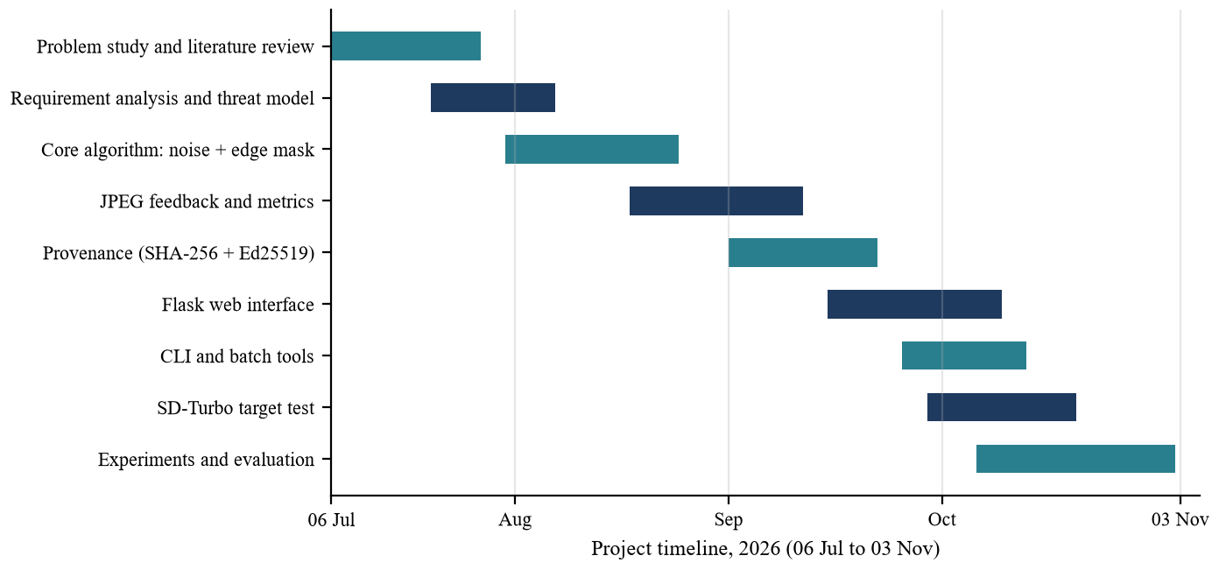
Fig. 5.1 Project Timeline from 06 July to 03 November 2026
5.3 Milestones
Milestones were chosen so that each represents a state of the system that can be demonstrated. Table 5.2 lists them with the evidence that they were reached.
Table 5.2 Project Milestones and Evidence of Completion
ID | Milestone | Evidence | Target
M1 | Scope and threat model agreed | Report outline with problem statement, objectives, threat model and metrics | Week 5
M2 | First protected image | Protected PNG with bounded perturbation and noise preview from the protector | Week 8
M3 | Metrics and compression tests | PSNR, SSIM, MSE, deltas and JPEG results for any image | Week 10
M4 | Signed provenance | Manifest written and verified; tampering detected | Week 11
M5 | Working web application | Upload, protect, inspect and download in the browser | Week 13
M6 | Batch experiments | summary.csv produced for a folder of images | Week 14
M7 | Target-model comparison | SD-Turbo outputs for original and protected images | Week 15
M8 | Final report and demonstration | This report and the demonstration described in Chapter 6 | Week 17

The output folder of the repository holds evidence for the later milestones: eighteen web-interface runs recorded on 8 October 2026, all with a verified provenance manifest, and two of them with SD-Turbo outputs.
5.4 Risks and Mitigation
Seven risks were identified at the start and monitored during the project. They are listed with the mitigation that was applied in Table 5.3.
Table 5.3 Risk Register
ID | Risk | Impact | Mitigation | Status
R1 | Protection too visible | High | Bounded budget, edge-aware mask, PSNR and SSIM reported for every run | Mitigated
R2 | Perturbation destroyed by JPEG | High | JPEG feedback loop and robustness table at several qualities | Partly mitigated
R3 | SD-Turbo needs a GPU and a large download | Medium | Model test is optional and isolated; rest of system runs without it | Mitigated
R4 | Model failure crashes the web server | High | Separate worker process with timeout and error message | Mitigated
R5 | Over-claiming protection | High | Wording in the interface and report limited to what is measured | Mitigated
R6 | Private key exposure | Medium | Key folder excluded from version control; local-only server | Accepted for prototype
R7 | Scope growth (more models, video) | Medium | Scope fixed to images and one target model; others listed as future work | Mitigated

Risk R2 is only partly mitigated because compression at low quality removes most of the perturbation, as Chapter 7 shows. Risk R6 is accepted because encrypting the key would complicate the demonstration, and it is noted among the recommendations of Chapter 8.
5.5 Quality Assurance and Review Practice
Quality assurance was planned around repeatable runs and regular review of outputs rather than a heavy process. A change to the algorithm can be judged by running the pipeline on the same test image with a fixed seed and comparing the metric table, the difference image and the JPEG results with the previous run. Because the pipeline is deterministic for a given seed, differences between runs are attributable to the change and not to chance, and the web application stores every run in its own folder, so earlier results remain available for comparison. Reviews with the project guide were planned around the milestones in Table 5.2, with the working system demonstrated at each review. The same discipline was applied to the report: every number in Chapter 7 is generated by a script from the library code and stored in a data file, so the report can be regenerated if the algorithm changes.
CHAPTER 6
PROJECT DEMONSTRATION
This chapter demonstrates the working system. It follows the path that a user takes through the web interface, shows the outputs of real runs that were recorded in the output folder of the project during development, and then shows the command-line workflow and the behaviour of the system in error situations. All figures in this chapter are produced by the project code from the images named in the text; none is a mock-up except Fig. 6.1, which is a schematic drawn from the page template to explain the layout.
6.1 Demonstration Setup
The demonstration environment is a Windows computer with Python 3.12 and the project's virtual environment. The web server is started with the launch script or with the virtual environment's interpreter running app.py, after which the interface is opened in a browser at the address http://127.0.0.1:5000. For the optional model test an NVIDIA GPU, the CUDA build of PyTorch and the SD-Turbo snapshot in models/sd-turbo/ are required. All runs shown below used the default controls unless stated otherwise: a perturbation budget of 8, four feedback iterations, seed 42 and JPEG tests at qualities 95, 75 and 50.
6.2 Walkthrough of the Web Interface
Fig. 6.1 shows the layout of the workspace. The sidebar on the left holds the protection settings. The central area contains an upload panel with a drag-and-drop zone and the Protect image button, and a result panel that is empty until a run completes. Four detail panels, for quality metrics, the compression table, inspection images and provenance, appear below the result after a run, followed by the SD-Turbo panel if the model test was requested.
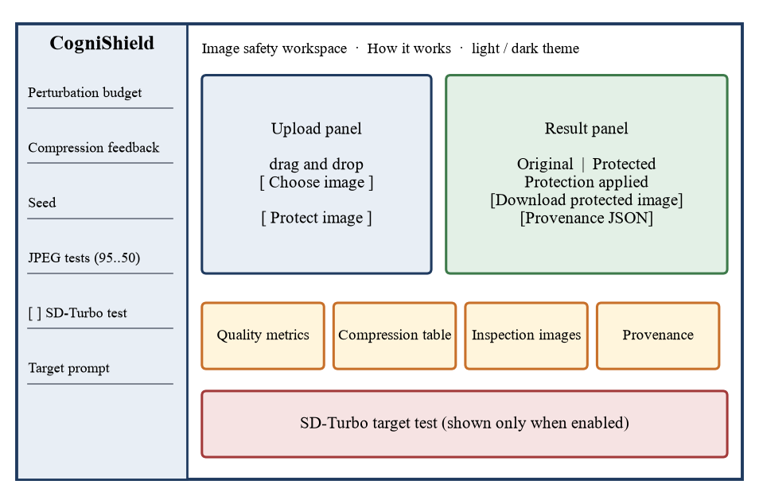
Fig. 6.1 Schematic Layout of the CogniShield Web Interface
A typical session consists of the steps in Table 6.1.
Table 6.1 Steps of a Demonstration Session
Step | User action | System response
1 | Open http://127.0.0.1:5000 | The workspace loads in dark mode; the Protect button is disabled
2 | Drag an image into the upload zone, or click Choose image | A preview and the file name appear; the button is enabled and a status line asks the user to review the settings
3 | Adjust budget, feedback, seed and JPEG tests if desired | Sliders update their fill and value labels; the seed can be stepped with the plus and minus buttons
4 | Click Protect image | The button shows Protecting, the status chip changes to Processing
5 | Wait for the response | Original and protected images appear side by side with a success banner; details panels are shown
6 | Inspect metrics, compression table, difference image, noise preview and JPEG previews | Values from the JSON response are rendered
7 | Click Download protected image and Provenance JSON | The protected PNG and the signed manifest are saved
8 | Optionally tick Run SD-Turbo target test and enter a prompt | A second run shows the model outputs for the original and protected images

The top-right switch changes between dark and light themes and remembers the choice. The How it works page opens in the same tab and explains the flow in six cards: input, protection, quality, JPEG tests, provenance and the optional model test. The page also states the local-by-design property: the application runs at 127.0.0.1 and does not send the image to an external upload service.
6.3 Demonstration 1: Portrait Protection
The first demonstration uses a portrait photograph of 801 × 775 pixels, taken from the team's own project runs. Fig. 6.2 shows the original, the protected image, the difference image magnified twelve times and the noise preview. At normal size the original and protected images cannot be told apart by eye. The magnified difference shows a fine, speckled pattern that is strongest along the hair, the eyes and the clothing edges and weaker on the skin, which is the behaviour that the edge mask is designed to produce. The noise preview shows the same pattern as a fraction of the budget.
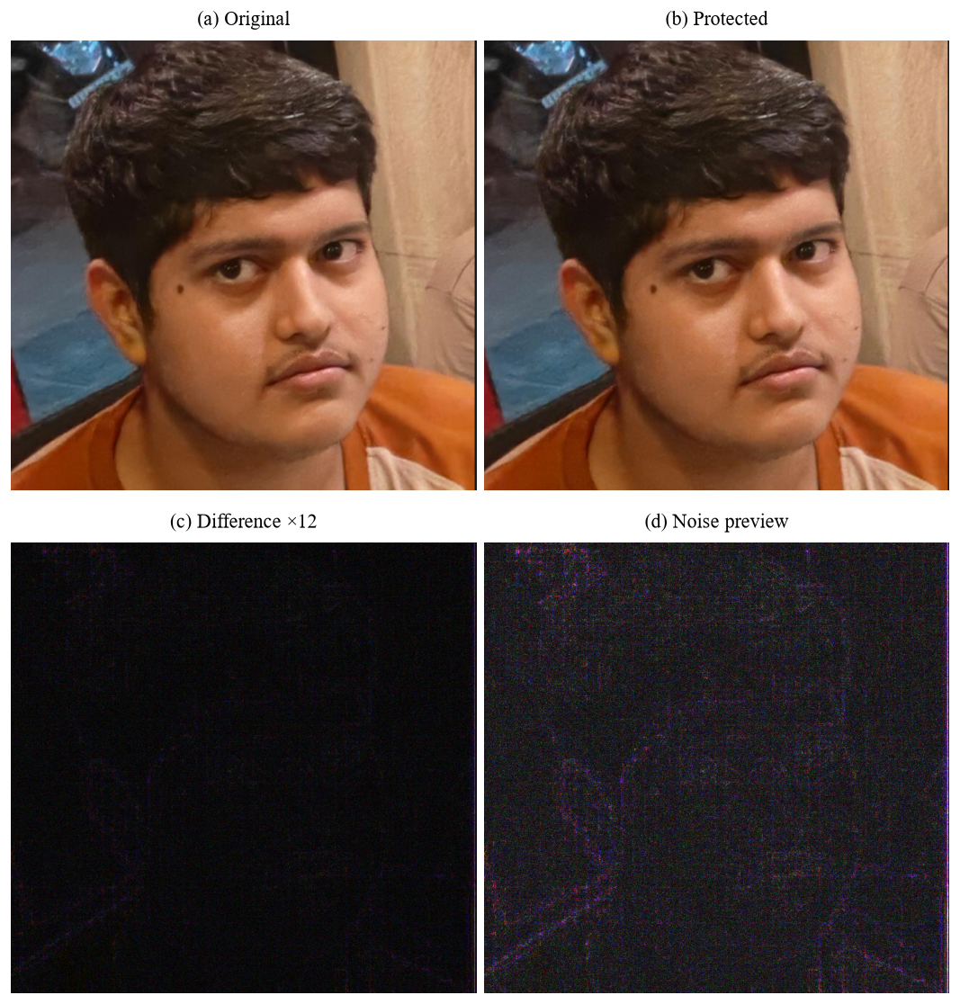
Fig. 6.2 Portrait Run at the Default Settings: Original, Protected, Difference ×12 and Noise Preview
The metrics for this run are listed in Table 6.2. The PSNR of 45.49 dB is well above the 30 dB guideline, the SSIM of 0.9831 is close to 1.0, the average pixel changed by about 1.00 level out of 255 and the largest change was exactly 8 levels, the selected budget. The run took about 0.52 seconds on the machine used for the experiments, including noise generation, the feedback loop and the metric computation for a single image.
Table 6.2 Metrics of the Portrait Run (Budget 8/255, Four Iterations, Seed 42)
Metric | Value
PSNR | 45.49 dB
SSIM | 0.9831
MSE | 0.28 × 10⁻⁴
Mean absolute delta | 1.00 levels
Maximum absolute delta | 8.00 levels
PSNR after JPEG q=95 / 75 / 50 | 45.12 / 42.10 / 39.48 dB
SSIM after JPEG q=95 / 75 / 50 | 0.9838 / 0.9716 / 0.9569

6.4 Demonstration 2: JPEG Variants
The interface writes one JPEG file for every selected quality and shows them next to the metric table. Fig. 6.3 shows the three variants of the protected portrait. The PSNR values in Table 6.2 fall from 45.12 dB at quality 95 to 39.48 dB at quality 50, and most of this decrease is caused by compression itself, not by the perturbation: Section 7.5 shows that for the average image the protected and unprotected JPEG results are within 0.16 dB of one another at quality 50. At all three qualities the images look alike at normal size, with block artefacts becoming noticeable at quality 50 on smooth regions.
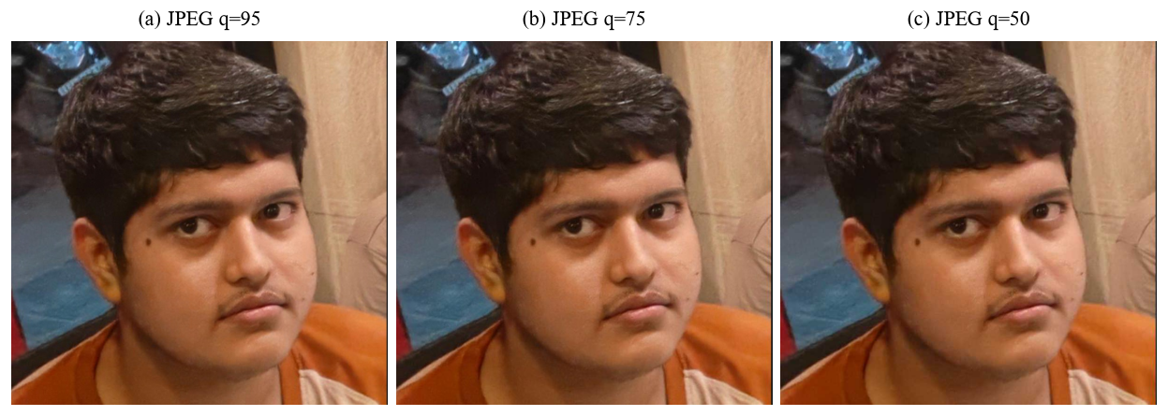
Fig. 6.3 Protected Portrait After JPEG Compression at Qualities 95, 75 and 50
6.5 Demonstration 3: Signed Provenance
After the protected PNG is written, the application signs it and immediately verifies the signature. The manifest of the portrait run is reproduced in the listing below. The digest is the SHA-256 of the protected PNG, the signature is the 64-byte Ed25519 signature encoded in base64, and the metadata record the settings used.
{
"project": "CogniShield",
"algorithm": "Ed25519 over SHA-256(image_bytes)",
"image_file": "protected.png",
"image_hash_sha256": "72f0d265dd32131476100d7847719ce044fae02c3c2396baba88f6d8ac8ae954",
"signature_base64": "fYUaYdHDCzgSWL5Rlv02j+OJF46tuxPzAPj1ciZLShFnSlyZS7aVDWx+7x2ruVXYHZSlnmdEwzSK1pcBhWw9CQ==",
"public_key_file": "cognishield_public.pem",
"signed_at_utc": "2026-10-08T19:41:40.309030+00:00",
"metadata": {
"source_filename": "Screenshot_2026-10-08_233221.png",
"epsilon": 0.03137254901960784,
"epsilon_pixels": 8, "iterations": 4, "seed": 42,
"jpeg_qualities": [95, 75, 50]
}
}
Two checks were performed on the recorded runs. First, the SHA-256 digest of every one of the 18 protected images in the web output folder was recomputed and compared with the digest stored in its manifest; all 18 matched. Second, to emulate tampering, one bit in the middle of each protected file was flipped in memory and the digest recomputed; in 0 of the 18 cases did the altered file's digest still equal the recorded one. Because the signature covers the digest, a changed digest cannot verify. The signature length was 64 bytes in every manifest, as expected for Ed25519. The signature check itself is performed by the application at the end of every protection request, and the interface reports the result in the provenance panel together with the digest.
6.6 Demonstration 4: SD-Turbo Target Test
To observe the effect on a generative model, the portrait was passed through the local SD-Turbo image-to-image pipeline with the default prompt, a realistic portrait photograph with natural lighting, the same seed for both inputs and the strength and step settings of Section 4.1.12. The input was resized to 512 × 488 pixels, as the model requires multiples of eight. Fig. 6.4 shows the output for the original image and for the protected image.
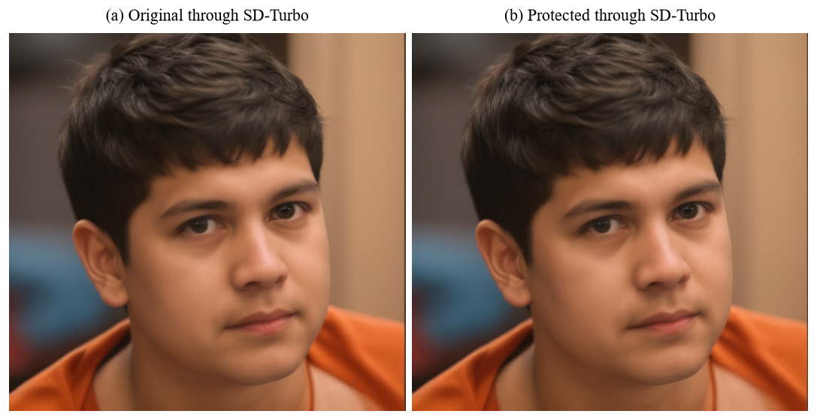
Fig. 6.4 SD-Turbo Image-to-Image Outputs for the Original and the Protected Portrait
Both outputs show a regenerated, smoothed version of the person with the same pose, hair and background colours, which is what image-to-image generation with moderate strength produces. The two outputs are visually almost identical. Fig. 6.5 quantifies this by showing the absolute difference between them, magnified twelve times, and its histogram. The PSNR between the two outputs is 41.06 dB and their SSIM is 0.9863. Section 7.10 interprets this result: at the default settings the perturbation is far too small to make this particular model visibly fail, which is a limitation of the gradient-free design and not a defect in the test. Two separate runs of the model test on the same input gave outputs with identical metrics, confirming that the seeded test is repeatable.
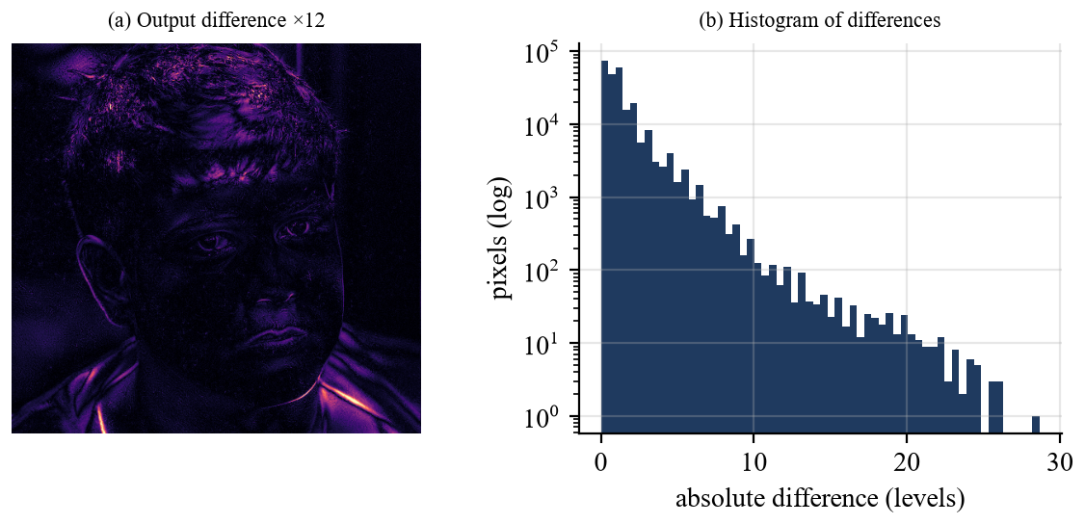
Fig. 6.5 Difference Between the Two SD-Turbo Outputs, Magnified Twelve Times, and Its Histogram
6.7 Demonstration 5: Other Images
The system was also run on images with very different content. Fig. 6.6 shows a colour portrait with texture from the scikit-image sample data, and Fig. 6.7 shows a photograph of a handwritten notebook page from the team's own runs, which has large flat regions of paper and fine pen strokes. In both cases the protected images are indistinguishable from the originals at normal size, and the difference images concentrate on the strokes, the textures and the borders. The notebook page is also a useful stress case for the edge mask because most of its area is nearly uniform: the initial perturbation there is limited to the 35 percent floor of the budget, although the feedback term can raise it, as the noise preview in the figure shows.
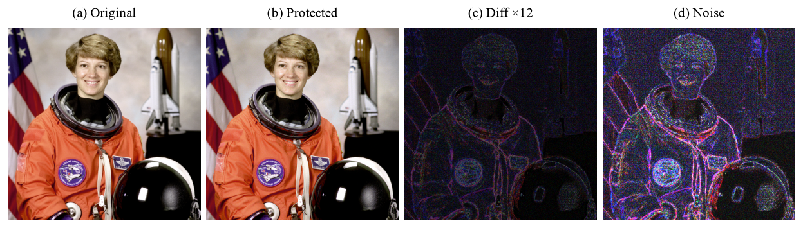
Fig. 6.6 Protection of a Colour Portrait From the Sample Data
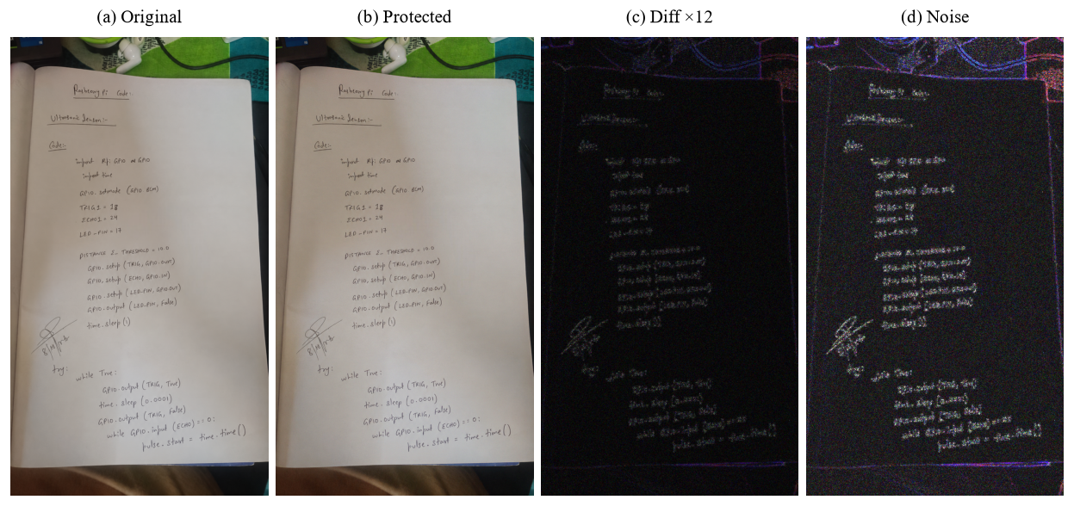
Fig. 6.7 Protection of a Handwritten Notebook Page
6.8 Demonstration 6: Command-Line and Batch Workflow
For automation, the same pipeline can be driven from the command line. Running the single-image program on a file writes a folder named after the file, which contains the protected PNG, the noise preview, the difference image, a JPEG file for each quality, the manifest and a report.json that combines the input and output paths, the metrics, the compression results and the verification result. The same report is printed to the terminal. The batch program applies the protection to every image in the input folder and writes summary.csv, which has one row per image with its width, height, PSNR, SSIM, MSE, mean absolute delta, maximum absolute delta and the PSNR and SSIM at each JPEG quality. The experiments reported in Chapter 7 were produced by calling the same library functions that these programs call, on 14 images, and so the data in the tables correspond to what the batch program would produce for the same inputs.
6.9 Behaviour in Error Situations
A usable tool must fail clearly. Table 6.3 lists test cases for the behaviour of the web application in normal and abnormal situations, with the expected response according to the implementation and how it was checked.
Table 6.3 Functional Test Cases and Expected Behaviour
ID | Case | Expected behaviour | Checked by
TC1 | Valid PNG with default settings | Success response with images, metrics, compression table and a valid provenance result | Recorded web runs
TC2 | Protect pressed with no file | HTTP 400, message to choose an image first | Code review
TC3 | File with an unsupported extension | HTTP 400, message to use PNG, JPG, JPEG or WEBP | Code review
TC4 | Unreadable file with a valid extension | HTTP 400, message that the file could not be read as an image | Code review
TC5 | Budget outside 1–16 or iterations outside 0–8 | Value clamped to the allowed range | Code review
TC6 | No JPEG quality ticked | Default qualities 95 and 75 are used | Code review
TC7 | Upload larger than 200 MB | HTTP 413, message about the 200 MB limit | Code review
TC8 | SD-Turbo requested without the model folder | Protection succeeds; the model panel reports that the directory was not found | Code review
TC9 | Same image, seed and settings twice | Bit-identical protected images | Experiment, Section 7.8
TC10 | One bit of the protected file changed | Digest differs from the manifest; verification fails | Experiment, Section 7.9

The web application also tolerates operating-system level failure of the model test: if the worker process exits abnormally or exceeds the five-minute limit, the application reports this and still returns the signed protection result.
CHAPTER 7
COST ANALYSIS / RESULT & DISCUSSION
This chapter reports the experimental evaluation of CogniShield and then discusses what the results mean, what they do not show and what the system costs to build and to run. All numbers in this chapter were produced by running the project's own library functions (protect_image, calculate_metrics, jpeg_roundtrip and the provenance hashing) and were written to a data file from which the tables and figures were generated, so each value can be reproduced.
7.1 Experimental Setup
7.1.1 Test images
The evaluation uses 14 images, listed in Table 7.1 and shown in Fig. 7.1. Two are images from the team's own recorded runs, a portrait photograph and a photograph of a handwritten notebook page. The remaining twelve are sample images that ship with the scikit-image library and were chosen to cover different content: photographs of people, animals and objects, three textures (brick, grass and gravel), two grayscale images, a microscopy image, an astronomical image and a retinal image. The two largest images were reduced to at most 800 pixels on the longer side and the notebook photograph to at most 1000 pixels to keep experiments quick. Grayscale images are converted to three-channel RGB by the same loading rule that the application uses.
Table 7.1 Test Images Used in the Experiments
No. | Image | Content | Size (px) | Source
1 | portrait | Portrait photograph | 801 × 775 | Project run (web app)
2 | notebook | Handwritten notebook page | 562 × 1000 | Project run (web app)
3 | astronaut | Portrait with texture | 512 × 512 | scikit-image data
4 | coffee | Still life | 600 × 400 | scikit-image data
5 | chelsea | Cat photograph | 451 × 300 | scikit-image data
6 | rocket | Outdoor object | 640 × 427 | scikit-image data
7 | immunohistochemistry | Microscopy stain | 512 × 512 | scikit-image data
8 | brick | Texture | 512 × 512 | scikit-image data
9 | grass | Texture | 512 × 512 | scikit-image data
10 | gravel | Texture | 512 × 512 | scikit-image data
11 | camera | Photographer, grayscale | 512 × 512 | scikit-image data (grayscale)
12 | moon | Lunar surface, grayscale | 512 × 512 | scikit-image data (grayscale)
13 | hubble | Astronomical field | 800 × 697 | scikit-image data (resized)
14 | retina | Retinal fundus | 800 × 800 | scikit-image data (resized)

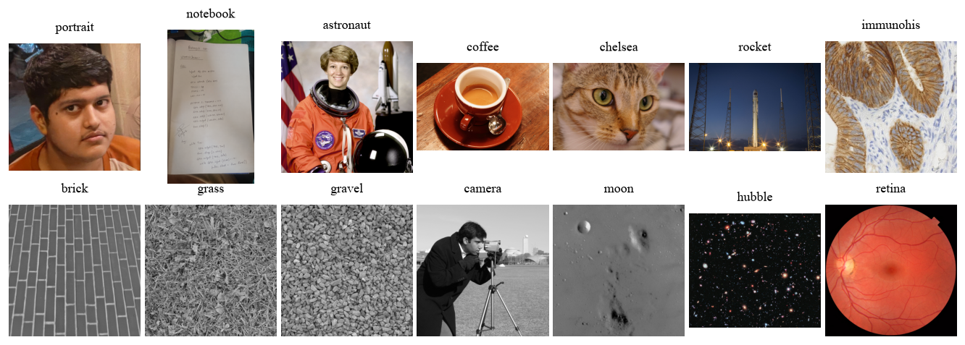
Fig. 7.1 Contact Sheet of the 14 Test Images
7.1.2 Protocol
Unless a section states otherwise, every experiment uses the default configuration of the web interface: a budget of 8/255, four feedback iterations, seed 42 and feedback qualities 95, 75 and 50. For each image the original is compared with the protected image, and with the protected image after JPEG round trips at qualities 95, 75 and 50. As a baseline, the original is also compared with its own JPEG round trip at the same qualities, so that the cost of compression alone can be separated from the cost of the perturbation. Sensitivity studies vary one parameter at a time on a subset of four images, the portrait, the colour portrait, the still life and the notebook page, and average the results. All experiments ran on CPU on a Windows 11 computer with Python 3.12.
7.1.3 Measures
The measures are those defined in Section 4.1.9: PSNR, SSIM, MSE, mean and maximum absolute delta. For the study of how much of the perturbation survives a transformation T, a further measure is introduced for this report. Let δ be the perturbation added to an image x, so that the protected image is x + δ. The retention ρ_{T} is the coefficient obtained by projecting the change that T leaves between the transformed protected and transformed original images onto δ, as in Eqn. 7.1. A value of 1 means that the perturbation passes through the transformation unchanged along its own direction, a value near 0 means that it has been removed, and values above 1 can occur when the transformation interacts with the image content. The measure is a linear proxy for how much of the protective signal remains; it does not measure the effect on a generative model.
$ρ_{T}=\frac{⟨δ, T(x+δ)-T(x)⟩}{{\left\|δ\right\|}^{2}}$ (7.1)
7.2 Imperceptibility of the Protection
Table 7.2 reports the metrics for each image at the default settings, and Fig. 7.2 plots PSNR and SSIM per image. All 14 images exceed the 30 dB guideline: the mean PSNR is 41.56 dB with a standard deviation of 2.72 dB, the lowest value is 38.07 dB for the grass texture and the highest is 45.78 dB for the moon image. All images also have an SSIM above 0.95, with a mean of 0.9800; the lowest value is 0.9618 for hubble and the highest is 0.9938 for grass. The mean squared error is of the order of 10⁻⁴, the average pixel changes by 1.62 levels out of 255 (between 0.97 and 2.49 across images) and the maximum absolute change is exactly 8.00 levels in every case, which confirms that the clip enforces the budget.
Table 7.2 Imperceptibility Metrics at the Default Settings (ε = 8/255, 4 Iterations, Seed 42)
Image | PSNR (dB) | SSIM | MSE (×10⁻⁴) | Mean abs. Δ (levels) | Max abs. Δ (levels) | Time (s)
portrait | 45.49 | 0.9831 | 0.28 | 1.00 | 8.00 | 0.52
notebook | 44.02 | 0.9788 | 0.40 | 1.12 | 8.00 | 0.35
astronaut | 39.79 | 0.9763 | 1.05 | 1.82 | 8.00 | 0.17
coffee | 38.66 | 0.9703 | 1.36 | 2.16 | 8.00 | 0.17
chelsea | 41.04 | 0.9813 | 0.79 | 1.66 | 8.00 | 0.10
rocket | 39.11 | 0.9703 | 1.23 | 1.82 | 8.00 | 0.21
immunohistochemistry | 40.82 | 0.9880 | 0.83 | 1.78 | 8.00 | 0.20
brick | 44.41 | 0.9860 | 0.36 | 1.13 | 8.00 | 0.18
grass | 38.07 | 0.9938 | 1.56 | 2.49 | 8.00 | 0.21
gravel | 39.86 | 0.9935 | 1.03 | 2.01 | 8.00 | 0.22
camera | 41.79 | 0.9820 | 0.66 | 1.46 | 8.00 | 0.19
moon | 45.78 | 0.9798 | 0.26 | 0.97 | 8.00 | 0.20
hubble | 38.71 | 0.9618 | 1.35 | 2.24 | 8.00 | 0.50
retina | 44.24 | 0.9747 | 0.38 | 1.11 | 8.00 | 0.51
Mean | 41.56 | 0.9800 | 0.82 | 1.62 | 8.00 | 0.27

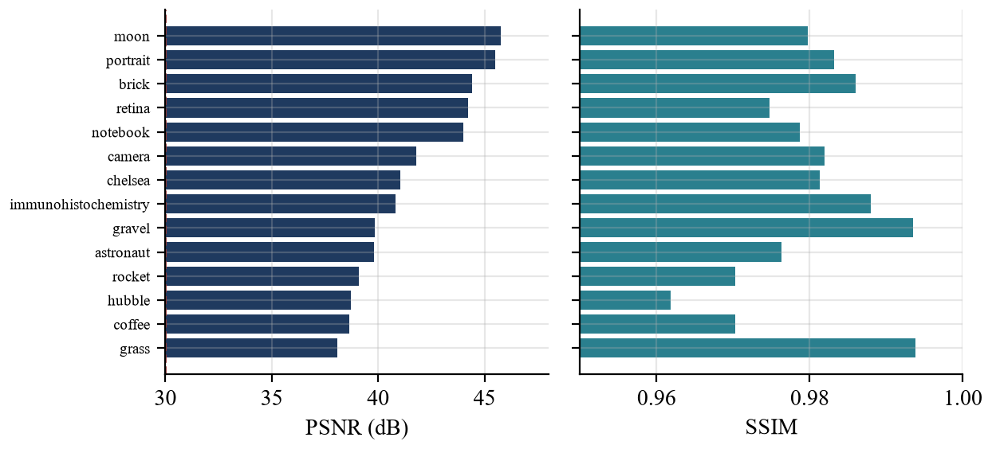
Fig. 7.2 PSNR and SSIM of the Protected Images at the Default Settings
The ordering of the images shows how content influences the cost of protection. Images with a lot of fine detail, such as the grass texture, the astronomical field and the still life, have lower PSNR because the edge mask directs more of the budget to them, so their average pixel change is larger. Smooth images, such as the lunar surface and the portrait, have the highest PSNR. PSNR and SSIM do not rank the images identically: the grass texture has the lowest PSNR of all images but the highest SSIM, and the gravel texture has a below-median PSNR and the second-highest SSIM. This is expected, because SSIM is partly insensitive to small changes in regions of high local variance, where texture masks the perturbation, which is also the property that the edge mask exploits.
Fig. 7.3 shows the distribution of the integer pixel changes for the colour portrait. The histogram is concentrated near zero, falls off rapidly towards the budget limits at plus and minus 8 levels, and is symmetric, which reflects the zero-mean noise. Only a small fraction of the pixels reaches the extreme values, because the product of the normalised noise and the mask is rarely at its maximum.
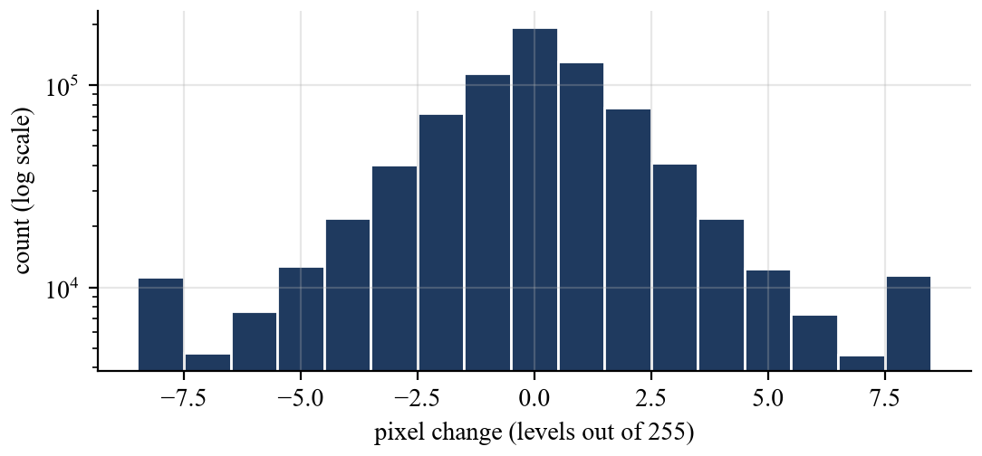
Fig. 7.3 Distribution of Pixel Changes for the Colour Portrait (Budget 8/255)
7.3 Effect of the Perturbation Budget
The budget is the main control, and Table 7.3 and Fig. 7.4 show its effect. PSNR falls from 50.25 dB at a budget of 1 to 39.06 dB at a budget of 16, a decrease of 11.18 dB over a sixteen-fold increase in the allowed change, and SSIM falls from 0.9953 to 0.9508. The maximum absolute change follows the budget exactly. Even at the largest budget the mean PSNR is well above 30 dB. A pure doubling of the perturbation amplitude would lower PSNR by about 6 dB, but the measured decrease per doubling is smaller, between 2.5 and 3.2 dB; a likely reason is that the final conversion to 8-bit integers and the feedback loop make the realised perturbation grow more slowly than the budget.
Table 7.3 Effect of the Perturbation Budget ε (Mean of 4 Images, 4 Iterations)
ε (of 255) | PSNR (dB) | SSIM | Mean abs. Δ (levels) | Max abs. Δ (levels) | ρ at q=75 | ρ at q=50
1 | 50.25 | 0.9953 | 0.63 | 1.00 | 0.43 | 0.28
2 | 47.07 | 0.9915 | 0.89 | 2.00 | 0.50 | 0.29
4 | 44.46 | 0.9863 | 1.18 | 4.00 | 0.53 | 0.25
6 | 43.03 | 0.9819 | 1.36 | 6.00 | 0.52 | 0.22
8 | 41.99 | 0.9771 | 1.52 | 8.00 | 0.48 | 0.19
10 | 41.13 | 0.9717 | 1.67 | 10.00 | 0.44 | 0.16
12 | 40.37 | 0.9655 | 1.82 | 12.00 | 0.39 | 0.14
16 | 39.06 | 0.9508 | 2.13 | 16.00 | 0.32 | 0.11

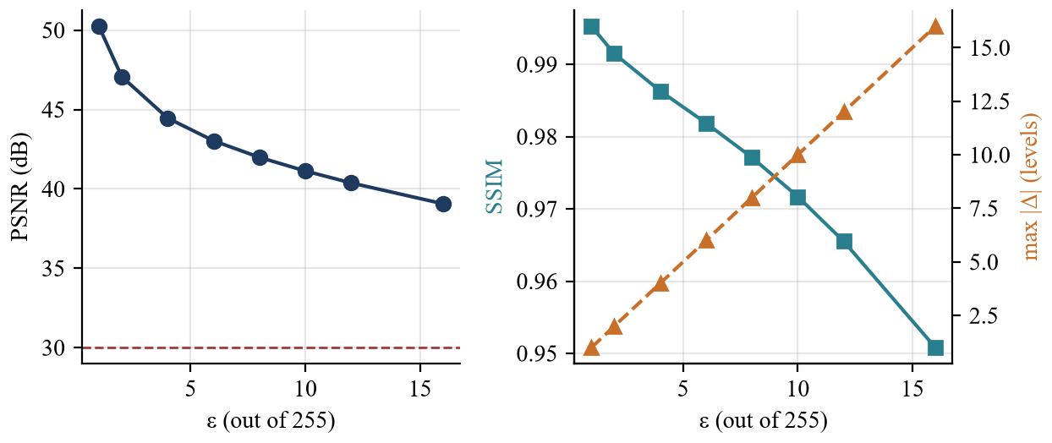
Fig. 7.4 Effect of the Perturbation Budget on PSNR, SSIM and Maximum Change
The retention columns of Table 7.3 show that a larger budget does not translate into a larger surviving fraction. For JPEG at quality 75 the retention is 0.43 at a budget of 1, rises to 0.53 at a budget of 4, is 0.48 at the default of 8 and falls to 0.32 at 16; for quality 50 it falls monotonically from 0.29 at a budget of 2 to 0.11 at 16. Because the retention is normalised by the energy of the perturbation, this means that the compression removes proportionally more of a large perturbation, which suggests that raising the budget buys less additional robustness than it costs in quality, and that moderate budgets between 4 and 8 give the best balance in these measurements.
7.4 Effect of the Compression Feedback
Table 7.4 and Fig. 7.5 show how the number of feedback iterations changes quality and retention. Without feedback the perturbation is only the masked noise; its PSNR is 51.90 dB and the retention is 0.21, 0.10 and 0.07 at qualities 95, 75 and 50. With the default four iterations the PSNR is 41.99 dB and the retention is 0.55, 0.48 and 0.19. Feedback therefore multiplies the surviving fraction at quality 95 by about 2.7 and at quality 75 by about 5.0, which is the intended effect of the loop.
Table 7.4 Effect of the Number of Compression-Feedback Iterations (Mean of 4 Images, ε = 8/255)
Iterations | PSNR (dB) | SSIM | ρ at q=95 | ρ at q=75 | ρ at q=50 | PSNR of JPEG q=50 (dB)
0 | 51.90 | 0.9960 | 0.21 | 0.10 | 0.07 | 34.62
1 | 49.27 | 0.9942 | 0.37 | 0.33 | 0.20 | 34.62
2 | 46.23 | 0.9906 | 0.48 | 0.46 | 0.22 | 34.59
3 | 43.84 | 0.9849 | 0.53 | 0.50 | 0.21 | 34.54
4 | 41.99 | 0.9771 | 0.55 | 0.48 | 0.19 | 34.47
5 | 40.49 | 0.9674 | 0.56 | 0.46 | 0.17 | 34.40
6 | 39.23 | 0.9558 | 0.56 | 0.43 | 0.15 | 34.34
7 | 38.14 | 0.9423 | 0.55 | 0.39 | 0.13 | 34.28
8 | 37.17 | 0.9271 | 0.54 | 0.36 | 0.11 | 34.22

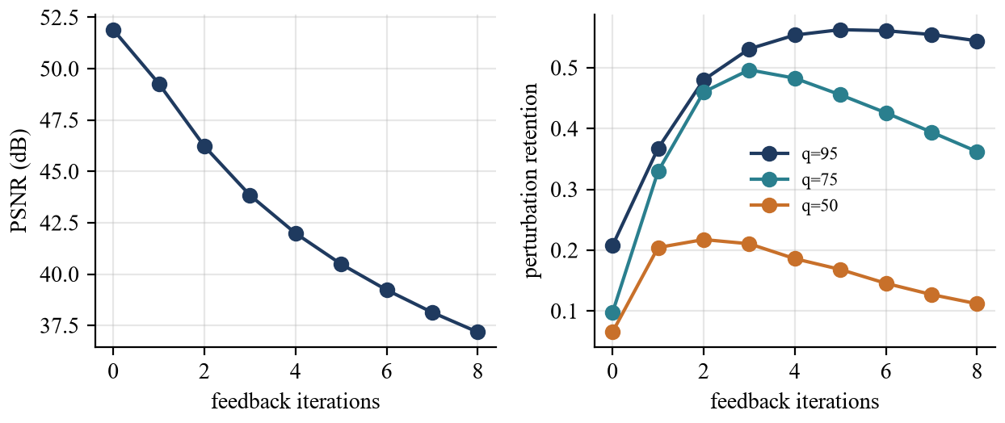
Fig. 7.5 Effect of the Number of Feedback Iterations on PSNR and Perturbation Retention
Two cautions apply. First, the improvement is bought with a larger perturbation: the PSNR decreases by about 9.9 dB between zero and four iterations, and by a further several decibels up to eight iterations, where it reaches 37.17 dB with an SSIM of 0.9271. Second, the benefit saturates and then reverses. The retention at quality 95 peaks at 0.56 after 5 iterations, and at quality 75 it peaks at 0.50 after 3 iterations before decreasing to 0.36 after eight, so more than three to four iterations are counter-productive for the lower qualities. The default of four is close to the plateau for quality 95, but two or three iterations give nearly the same retention at quality 75 (0.46 and 0.50) with a PSNR that is 4.2 and 1.9 dB higher than the default. This suggests that three iterations may be a better default; the choice was not changed in the evaluated version. Finally, the PSNR of the JPEG-compressed protected image at quality 50 barely changes with the number of iterations, from 34.62 dB to 34.22 dB, because at that quality the compression error dominates everything else.
7.4.1 Composition of the final perturbation
The worked example of Section 4.1.19 suggested that the final perturbation is not mainly the seeded noise. To measure this for all images, three quantities were computed at the default settings: the mean absolute size of the initial perturbation δ₀ and of the final perturbation, the fraction of pixel-channel values that sit at the budget limit, and the correlation of the final perturbation with the initial noise perturbation and with the image's own JPEG residual, defined as the mean over qualities 95, 75 and 50 of the difference between the image and its compressed version. Table 7.5 gives the results and Fig. 7.6 plots the two correlations.
Table 7.5 Composition of the Final Perturbation at the Default Settings
Image | Pixel-channels at the budget (%) | Mean abs. initial δ0 (levels) | Mean abs. final δ (levels) | Correlation with δ0 | Correlation with JPEG residual
portrait | 0.1 | 0.45 | 1.00 | 0.72 | 0.58
notebook | 0.4 | 0.46 | 1.12 | 0.62 | 0.68
astronaut | 2.9 | 0.47 | 1.82 | 0.34 | 0.85
coffee | 4.2 | 0.48 | 2.16 | 0.31 | 0.86
chelsea | 0.7 | 0.51 | 1.66 | 0.47 | 0.81
rocket | 6.5 | 0.46 | 1.82 | 0.33 | 0.82
immunohistochemistry | 0.4 | 0.54 | 1.78 | 0.48 | 0.80
brick | 0.0 | 0.52 | 1.13 | 0.75 | 0.57
grass | 2.9 | 0.53 | 2.49 | 0.32 | 0.90
gravel | 0.8 | 0.55 | 2.01 | 0.43 | 0.82
camera | 0.7 | 0.48 | 1.46 | 0.48 | 0.79
moon | 0.0 | 0.45 | 0.97 | 0.75 | 0.56
hubble | 3.7 | 0.47 | 2.24 | 0.30 | 0.81
retina | 0.2 | 0.45 | 1.11 | 0.59 | 0.71
Mean | 1.7 | 0.49 | 1.62 | 0.49 | 0.75

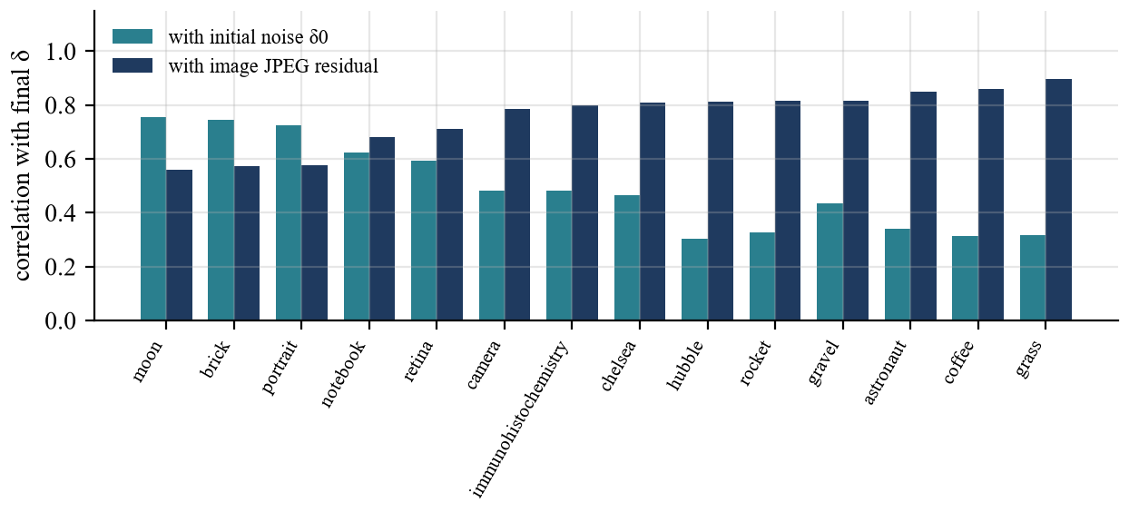
Fig. 7.6 Correlation of the Final Perturbation With the Initial Noise and With the Image's Own JPEG Residual
The initial perturbation is small, with a mean absolute size of 0.49 levels, and the final perturbation is about 3.3 times larger, at 1.62 levels. On average only 1.7 percent of the pixel-channel values reach the budget limit of 8 levels, at most 6.5 percent for rocket, so the budget is a ceiling that most pixels never touch, and the typical change is a small fraction of it. The correlation of the final perturbation with the image's own JPEG residual averages 0.75 and ranges from 0.56 for moon to 0.90 for grass, while its correlation with the initial noise averages 0.49 and is highest for moon (0.75). The initial noise and the JPEG residual are essentially uncorrelated with each other (the largest absolute correlation between them is 0.003), so the two correlations describe two distinct contributions. For smooth images such as the lunar surface, the portrait and the brick texture, the seeded noise still accounts for a visible share of the final perturbation; for textured images such as the grass, the still life and the astronomical field, the image's own residual dominates.
Two consequences follow. The protection is image-adaptive: its structure depends on the content as much as on the seed, which explains why different seeds change the quality figures so little (Section 7.8) and helps explain why the ratio of edge to flat perturbation in Section 7.7 exceeds what the mask alone can produce. And the effective strength of the protection is governed by how detailed the image is, not by the budget alone: for a smooth image the final perturbation is only about one level on average, which is why a large budget has a modest effect on PSNR in Section 7.3. These findings also qualify the notion of a "budget of 8": it bounds the worst case, and the typical change is much smaller.
7.5 Robustness to JPEG Compression
Table 7.6 compares, on average over the 14 images, the quality of the protected image after JPEG compression with the quality of the original after the same compression, and Table 7.7 gives the per-image values of the protected image. Fig. 7.7 shows the averages graphically. At quality 95 the protected image reaches 39.63 dB, which is 3.37 dB lower than the compressed original (43.00 dB), so the perturbation still makes a measurable contribution to the error. At quality 75 the difference shrinks to 0.94 dB and at quality 50 to 0.16 dB. This means that as compression becomes harsher, the compression error swamps the perturbation, and the protected and unprotected images become equally distant from the original.
Table 7.6 Mean Effect of JPEG Compression With and Without Protection (14 Images)
JPEG quality | PSNR: JPEG of original | PSNR: JPEG of protected | Gap (dB) | SSIM: JPEG of original | SSIM: JPEG of protected
95 | 43.00 | 39.63 | 3.37 | 0.9792 | 0.9687
75 | 36.22 | 35.29 | 0.94 | 0.9454 | 0.9363
50 | 33.96 | 33.80 | 0.16 | 0.9182 | 0.9158

Table 7.7 Quality of the Protected Image After JPEG Compression, Compared With the Original
Image | PSNR q=95 | PSNR q=75 | PSNR q=50 | SSIM q=95 | SSIM q=75 | SSIM q=50
portrait | 45.12 | 42.10 | 39.48 | 0.9838 | 0.9716 | 0.9569
notebook | 42.88 | 38.10 | 36.02 | 0.9774 | 0.9612 | 0.9505
astronaut | 37.47 | 33.66 | 32.00 | 0.9582 | 0.9334 | 0.9178
coffee | 36.40 | 31.87 | 30.40 | 0.9488 | 0.8975 | 0.8673
chelsea | 38.95 | 35.06 | 33.70 | 0.9710 | 0.9400 | 0.9170
rocket | 34.70 | 31.76 | 30.44 | 0.9482 | 0.9069 | 0.8833
immunohistochemistry | 38.64 | 34.54 | 32.78 | 0.9793 | 0.9509 | 0.9282
brick | 43.62 | 40.27 | 38.74 | 0.9860 | 0.9757 | 0.9698
grass | 35.99 | 26.72 | 26.89 | 0.9903 | 0.9278 | 0.9191
gravel | 37.61 | 31.82 | 30.35 | 0.9887 | 0.9593 | 0.9437
camera | 39.99 | 33.78 | 32.39 | 0.9769 | 0.9405 | 0.9115
moon | 45.11 | 42.23 | 40.87 | 0.9781 | 0.9639 | 0.9527
hubble | 34.63 | 31.79 | 30.78 | 0.9042 | 0.8303 | 0.7943
retina | 43.71 | 40.30 | 38.36 | 0.9716 | 0.9491 | 0.9091
Mean | 39.63 | 35.29 | 33.80 | 0.9687 | 0.9363 | 0.9158

Table 7.8 Perturbation Retention ρ After JPEG Compression for Each Image
Image | ρ at q=95 | ρ at q=75 | ρ at q=50
portrait | 0.38 | 0.34 | 0.17
notebook | 0.58 | 0.57 | 0.24
astronaut | 0.61 | 0.44 | 0.16
coffee | 0.65 | 0.57 | 0.17
chelsea | 0.81 | 0.55 | 0.17
rocket | 0.30 | 0.33 | 0.10
immunohistochemistry | 0.85 | 0.65 | 0.24
brick | 0.55 | 0.41 | 0.13
grass | 1.09 | 4.58 | 0.36
gravel | 0.97 | 1.04 | 0.29
camera | 0.88 | 1.08 | 0.26
moon | 0.52 | 0.33 | 0.10
hubble | 0.60 | 0.29 | 0.10
retina | 0.52 | 0.36 | 0.20
Median | 0.60 | 0.50 | 0.17

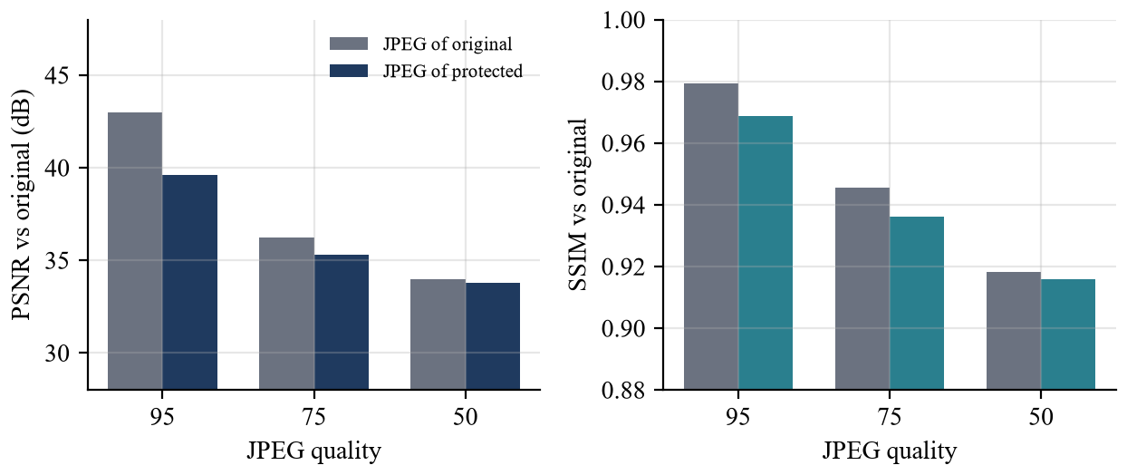
Fig. 7.7 Mean PSNR and SSIM After JPEG Compression, With and Without Protection
The retention measure gives a more direct view of how much of the perturbation survives. The median retention over the 14 images is 0.60 at quality 95, 0.50 at quality 75 and 0.17 at quality 50; the means are 0.66, 0.82 and 0.19. The mean at quality 75 is inflated by a single outlier, the grass texture, whose retention of 4.58 exceeds 1: for this image the quantisation at quality 75 presumably interacts strongly with the fine texture, and since the measure is not bounded by 1, the median is the more representative statistic. In summary, roughly half of the perturbation along its own direction survives at qualities 95 and 75 and less than a fifth survives at quality 50. These values are consistent with the discussion in Section 4.1.10: JPEG discards high-frequency coefficients, and a perturbation of a few levels does not survive coarse quantisation.
Compression also reveals which images are fragile. The astronomical image has the lowest SSIM after compression, 0.8303 at quality 75, not because of the perturbation but because its many small, bright objects on a dark background are damaged by the codec itself; its baseline compressed-original SSIM is similar. This is a reminder that quality figures after compression depend strongly on image content.
7.6 Robustness to Other Transformations
JPEG is not the only operation that images undergo. Table 7.9 reports the retention of the perturbation under five further transformations applied to six images, and Fig. 7.8 plots the means with their standard deviations. Adding independent Gaussian noise leaves the retention at 1.00 by construction, because noise independent of the perturbation does not remove it along its direction, although it may still disturb a model. Resizing the image to half its size and back retains only 0.18 of the perturbation, Gaussian blur with a radius of one pixel retains 0.28 and a 3 × 3 median filter retains 0.30. These operations are low-pass filters and remove high-frequency content, which is exactly where the perturbation lives.
Table 7.9 Perturbation Retention ρ Under Common Transformations (6 Images)
Transformation T | Mean ρ | Std. dev.
None (identity) | 1.00 | 0.00
JPEG, quality 95 | 0.55 | 0.18
JPEG, quality 75 | 0.47 | 0.11
JPEG, quality 50 | 0.17 | 0.04
Down-scale to 50% and back (bilinear) | 0.18 | 0.03
Gaussian blur, σ = 1 px | 0.28 | 0.04
Median filter, 3 × 3 | 0.30 | 0.07
Added Gaussian noise, σ = 4/255 | 1.00 | 0.00

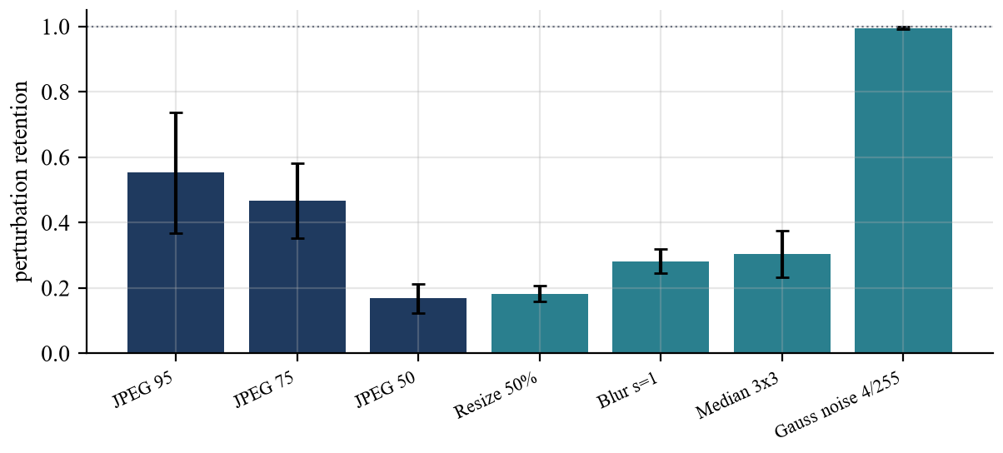
Fig. 7.8 Mean Perturbation Retention Under Compression and Filtering (Error Bars Show One Standard Deviation)
The consequence is a clear and honest limitation. Any sharing path that rescales, blurs or denoises the image removes most of the perturbation, and so a protection that relies on a high-frequency signal cannot be expected to survive such paths. This agrees with the limitations stated at the outset, namely that strong cropping, resizing, denoising or screenshots may weaken the perturbations. Making the perturbation robust to these operations would require lower-frequency or optimisation-based designs, which are listed as future work.
7.7 Edge-Aware Allocation of the Perturbation
The edge mask is meant to concentrate the perturbation on detailed regions. To verify this, the mean absolute perturbation was computed over the 10 percent of pixels with the largest gradient and over the 50 percent with the smallest gradient, and their ratio r, defined in Eqn. 7.2, was computed for every image. Table 7.10 and Fig. 7.9 show the results.
$r=\frac{mean |δ| over top-10\% gradient pixels}{mean |δ| over bottom-50\% gradient pixels}$ (7.2)
Table 7.10 Edge-Aware Allocation of the Perturbation (Values on the 0–1 Pixel Scale)
Image | Mean abs. δ at edges | Mean abs. δ in flat areas | Ratio r
portrait | 0.0050 | 0.0036 | 1.40
notebook | 0.0095 | 0.0036 | 2.65
astronaut | 0.0136 | 0.0047 | 2.89
coffee | 0.0163 | 0.0056 | 2.89
chelsea | 0.0107 | 0.0050 | 2.16
rocket | 0.0180 | 0.0036 | 5.04
immunohistochemistry | 0.0089 | 0.0062 | 1.44
brick | 0.0073 | 0.0034 | 2.12
grass | 0.0143 | 0.0083 | 1.72
gravel | 0.0109 | 0.0068 | 1.62
camera | 0.0113 | 0.0036 | 3.17
moon | 0.0056 | 0.0035 | 1.59
hubble | 0.0174 | 0.0070 | 2.48
retina | 0.0070 | 0.0035 | 2.01

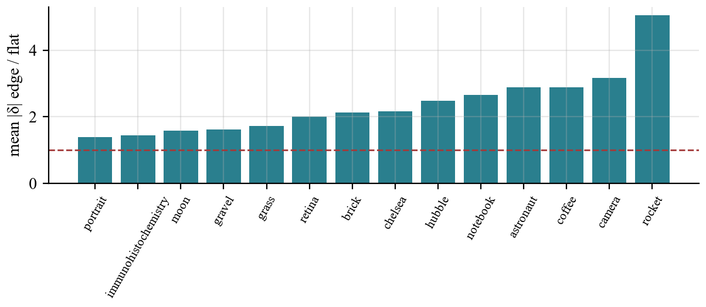
Fig. 7.9 Ratio of Mean Perturbation at Edges to Mean Perturbation in Flat Areas
The ratio exceeds 1 for all 14 images, with a mean of 2.37 and a median of 2.14, so the perturbation is indeed larger on average on detailed pixels than on flat ones. The ratio is largest for rocket (5.04) and smallest for portrait (1.40). The mask alone cannot explain the largest ratios. Its values span 0.35 to 1, so for noise of equal amplitude the ratio could not exceed about 2.9, yet rocket and camera exceed that value. The most likely additional cause is the feedback loop, because the JPEG residual that it adds back is itself largest at edges and textures and close to zero in flat areas, so the loop further concentrates the perturbation where the image has detail. Clipping at the limits of the intensity range in saturated regions may also play a role.
7.8 Reproducibility and Seed Sensitivity
Two runs with the same image, seed and settings produced identical protected images, bit for bit, which satisfies goal G4. Different seeds give different perturbations: the ten seeds of Table 7.11 gave 10 distinct output digests. The visual quality is stable across seeds. The PSNR ranges from 45.11 to 45.90 dB, with a standard deviation of 0.262 dB, and the SSIM from 0.9813 to 0.9849, so the choice of seed has a much smaller effect on quality than the choice of image or budget. Fig. 7.10 shows the PSNR per seed.
Table 7.11 Seed Sensitivity on the Portrait Image (ε = 8/255, 4 Iterations)
Seed | PSNR (dB) | SSIM | Output digest (first 12 hex)
0 | 45.65 | 0.9839 | 0a872d67319d
1 | 45.46 | 0.9830 | 3df51b11e313
2 | 45.89 | 0.9849 | 1cdcfae8416d
3 | 45.90 | 0.9849 | 513dcadae6a1
4 | 45.52 | 0.9833 | 5acb00455fd3
5 | 45.11 | 0.9813 | abe2958dc577
6 | 45.28 | 0.9822 | b0c411dbb296
7 | 45.83 | 0.9846 | f3d87dbb024a
8 | 45.75 | 0.9843 | 280bdbb81da9
9 | 45.57 | 0.9835 | c1a1914b75ca

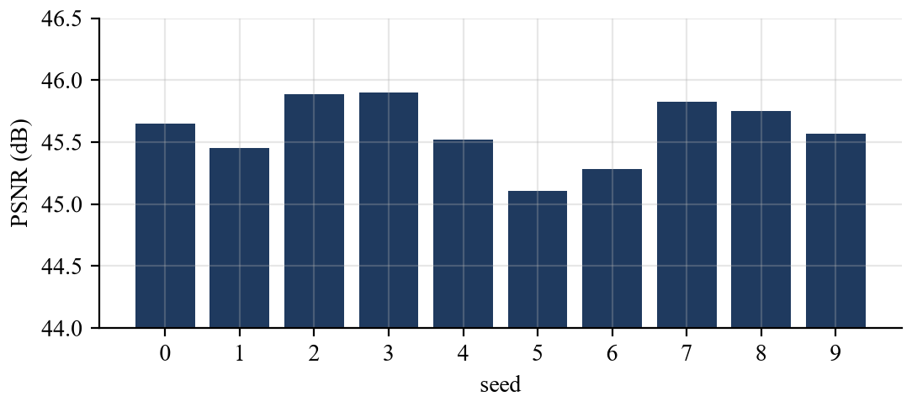
Fig. 7.10 PSNR of the Portrait Image for Ten Different Seeds
7.9 Provenance Verification
The provenance experiments, whose method is described in Section 6.5, used the 18 protected images recorded by the web application. Table 7.12 summarises the outcome. For every image the SHA-256 digest recomputed from the file equals the digest stored in the manifest, and flipping a single bit of the file makes the digest differ in every case. Since the signature is computed over the digest, a modified file cannot present a valid signature for the stored digest. The signature length was 64 bytes in every manifest. The signature verification itself is executed by the application on every request and its result is displayed to the user, so goal G5 is met at the level of the integrity of the exact file bytes.
Table 7.12 Provenance Integrity Results
Check | Result | Cases
Recomputed SHA-256 equals manifest digest | All match | 18 of 18
Digest equals manifest digest after one flipped bit | None match | 0 of 18
Signature length (Ed25519) | 64 bytes | 18 of 18
Hash-comparison failure reported before signature check | By design | Code review

It is important to restate what these results do and do not prove. They show that the manifest describes the exact bytes of the protected file and that tampering with the file is detectable. They do not show that the image depicts a real scene, who created it, or that it has not been copied elsewhere, and a user who can run the application can create valid signatures with their own key. The scheme therefore provides integrity and origin-from-this-installation, not authenticity of content.
7.10 Effect on the SD-Turbo Target Model
The target-model test was run on the portrait with the default prompt, strength and seed, as described in Section 6.6. Table 7.13 lists the measurements and Fig. 6.4 and Fig. 6.5 show the outputs and their difference. The PSNR between the SD-Turbo output for the original image and the output for the protected image is 41.06 dB and the SSIM is 0.9863. For comparison, the PSNR between the original and protected inputs is 45.49 dB with an SSIM of 0.9831. The mean absolute difference between the outputs is 1.35 levels, which is about 1.36 times the 1.00 level of the inputs.
Table 7.13 SD-Turbo Test on the Portrait Image
Measurement | Value
PSNR between inputs (original, protected) | 45.49 dB
SSIM between inputs | 0.9831
PSNR between model outputs | 41.06 dB
SSIM between model outputs | 0.9863
Mean absolute output difference | 1.35 levels
Output resolution | 512 × 488 pixels

The interpretation must be cautious. The model output changes by slightly more than the input does, which shows that the model does respond to the perturbation, but the amplification is only about 1.36 times and the outputs remain visually equivalent. In other words, at the default settings the perturbation does not disrupt this model in a way that a viewer would notice, and the result does not support a claim that the protected image resists SD-Turbo editing. This outcome is consistent with the design: the perturbation is model-agnostic noise, not an optimisation against the model's encoder or denoiser, and published immunization methods rely on such optimisation. The experiment is also limited to one image, one prompt and one seed. What the experiment does demonstrate is that the test harness works, is repeatable and exposes the effect, positive or negative, for any image and prompt. Section 8.4 lists target-model optimisation as the first item of future work.
7.11 Running Time and Scalability
Table 7.14 and Fig. 7.11 show the time of the protection step as the image side grows from 128 to 1024 pixels, using the colour portrait resized to square images. The time grows approximately linearly with the number of pixels, with a slope of about 0.75 seconds per megapixel, from 0.19 seconds for a 512 × 512 image to 0.75 seconds for 1024 × 1024. Over the 14 test images, the protection step took 0.27 seconds on average and at most 0.52 seconds. At this speed 1000 images of typical size would be protected in a few minutes of CPU time, so the batch workflow is not limited by the algorithm. The measured times exclude the metric computation, in which SSIM dominates, and the signing step, which is negligible, and they are specific to the machine used.
Table 7.14 Protection Time Versus Image Size (Three Runs, Median)
Side (px) | Pixels (×10⁶) | Median time (s)
128 | 0.016 | 0.001
256 | 0.066 | 0.027
384 | 0.147 | 0.097
512 | 0.262 | 0.188
768 | 0.590 | 0.466
1024 | 1.049 | 0.754

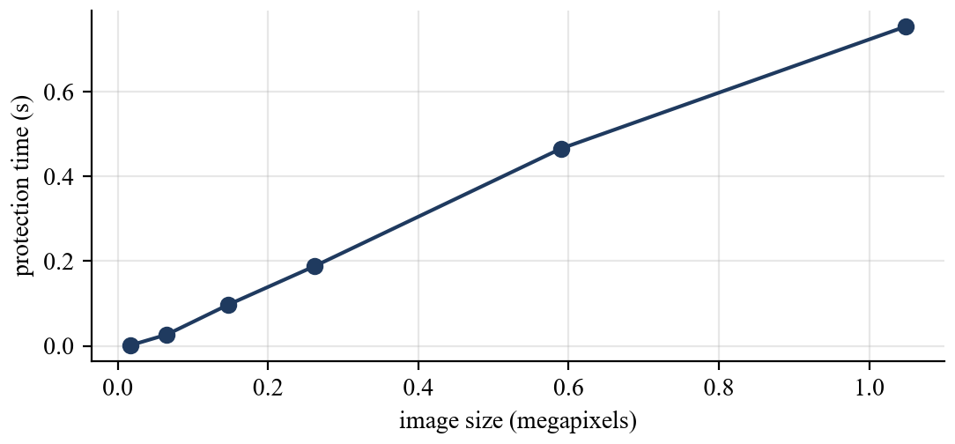
Fig. 7.11 Protection Time Versus Image Size
7.12 Discussion
7.12.1 Assessment against the project goals
Table 7.15 summarises the extent to which each goal of Section 2.4 was met.
Table 7.15 Assessment Against the Project Goals
ID | Goal | Status | Evidence
G1 | Imperceptible protection | Met | 14 of 14 images above 30 dB; mean PSNR 41.56 dB; mean SSIM 0.9800
G2 | Bounded change | Met | Maximum absolute change exactly 8.00 levels at budget 8 in all images
G3 | Compression awareness | Met, partly effective | Feedback raises retention at q=95 and 75; little survives at q=50
G4 | Reproducibility | Met | Identical outputs for identical settings
G5 | Verifiable provenance | Met | 18 of 18 digests match; no tampered file matches
G6 | Target-model comparison | Implemented | Side-by-side outputs and metrics; no visible disruption of SD-Turbo
G7 | Usability | Met by design | Single-page workflow with drag and drop and downloads
G8 | Local operation | Met by design | Loopback server; local storage of images and keys

7.12.2 Strengths
The prototype delivers what it promises on imperceptibility, reproducibility and integrity. The perturbation is small, strictly bounded, and measured at every run. The pipeline is fast enough for interactive use and for batch experiments. The provenance mechanism is simple, uses well-established primitives and fails safely. The architecture isolates the heavy optional component, and every stage of the process can be inspected through the images and numbers that the interface displays.
7.12.3 Limitations
The results also expose limitations that must be stated plainly. First, the protective effect on a generative model was not demonstrated: SD-Turbo output was nearly unchanged. Second, the perturbation is removed to a large degree by low-pass operations such as rescaling, blurring and median filtering and by coarse JPEG compression. Third, the signed provenance is invalidated by any re-encoding, so a platform that recompresses an upload produces a copy that no longer verifies. Fourth, the local key proves only that a file came from this installation, not who the person is. These limitations do not invalidate the prototype as a measurement and demonstration platform, but they bound the claims that may be made.
7.12.4 Threats to validity
The evaluation has several limits. The set of 14 images is small and contains no large collection of faces; the retention measure is a linear proxy and not a model-based effectiveness metric; the SD-Turbo experiment is limited to one image, one prompt and one seed; timings depend on the machine; and no study with human viewers was carried out, so imperceptibility is judged by PSNR and SSIM and by the authors' inspection of the images. The conclusions about parameters, such as the suggestion of fewer iterations, are therefore indicative.
7.13 Cost Analysis
7.13.1 Software and licensing cost
All software components used in CogniShield are available without licence fees. Table 7.16 lists the main components with their cost for this project. The model weights for SD-Turbo are distributed under the licence of their publisher, whose terms should be reviewed before any commercial use.
Table 7.16 Software and Resource Cost for the Prototype
Item | Source | Cost for this project
Python, NumPy, Pillow, scikit-image, Flask, cryptography | Open-source packages | No licence fee
PyTorch, diffusers, transformers, accelerate | Open-source packages | No licence fee
SD-Turbo model weights | Publisher's model hub | No fee; publisher's licence terms apply
Development tools and editor | Free tools | No licence fee
Test images | Team's own images and scikit-image sample data | No fee
Hosting and servers | Not used; runs locally | None

7.13.2 Hardware and running cost
The core pipeline needs no special hardware and ran on an ordinary Windows computer. A GPU is needed only for the optional model test, and the team used hardware it already had, so no hardware was purchased. The running cost of the core pipeline is the processor time of the protection step, about 0.27 seconds per image on average in the test set, which is about 4.4 minutes of CPU time per 1000 images, and the storage of the outputs, about 4.2 MB per run for an 801 × 775 image, which is about 4.2 GB per 1000 such images if all inspection images and JPEG variants are kept. The batch program stores the same kinds of files. Disk use can be reduced by deleting JPEG variants and inspection images, which are not part of the signed output.
7.13.3 Effort estimate
The project plan in Chapter 5 spans seventeen weeks for three students. As an illustration, if each team member contributed about eight hours per week, the total effort would be about 400 person-hours: this figure is an assumption for planning and costing purposes and not a record of hours worked. At typical junior-developer rates this would correspond to a development cost that is far larger than the running cost, which is the usual pattern for software of this kind. A deployed version would add costs for security review, key management, user support and compute for model-based optimisation.
7.14 Ethical and Societal Considerations
A tool that changes images and signs them touches several ethical questions, and the evaluation would be incomplete without them. The first is false confidence. The results of this chapter show that the evaluated perturbation does not visibly disrupt SD-Turbo and is largely removed by common processing, so presenting the tool as a shield could lead a user to believe that a photograph is safe when it is not. For this reason the interface and the report describe the output as a protected copy with measured properties and not as an immune image. The second is dual use. The same techniques can in principle be used to degrade other people's images or to make a manipulated image look signed; the design limits this by running locally on images that the user supplies and by making the provenance claim narrow, but the code could be misused like any other.
The third consideration is consent and data protection. The project uses the team's own photographs and public sample images, and the README directs users to process only images they own or are authorised to use. The portrait used in the demonstrations comes from the team's own project runs. The fourth is fairness of access: protection that requires a GPU or an account on a cloud service favours those who can afford it, whereas a tool that runs on an ordinary computer in a fraction of a second is more broadly available. The fifth is environmental cost: the core pipeline uses a negligible amount of computation per image, in contrast with iterative optimisation against large models, which is one argument for combining cheap, local protection with provenance before investing in heavier methods. Finally, any protection and provenance system should complement, and not replace, legal, platform and educational measures against image-based abuse.
CHAPTER 8
SUMMARY
This report presented CogniShield, a local prototype for edge-based adversarial immunization of digital images with cryptographic provenance. The project started from the observation that detection of manipulated images is reactive and that a complementary, proactive defence is worth exploring: an image owner could alter a photograph imperceptibly before publication so that it is harder to misuse, and sign the published file so that its integrity can be checked. The prototype turns this idea into a working pipeline that runs entirely on the user's own computer.
8.1 Summary of the Work
The system takes an input image, converts it to a floating-point RGB array and builds a seeded, high-frequency noise field. An edge mask derived from brightness gradients allocates more of the allowed change to detailed regions, and every pixel change is clipped to a budget of at most 16 and by default 8 levels out of 255. A feedback loop that uses the real JPEG encoder adds back a fraction of the residual that compression removes, so that more of the perturbation survives recompression. The protected PNG is accompanied by a noise preview and a difference image magnified twelve times. The tool then reports PSNR, SSIM, MSE, mean absolute delta and maximum absolute delta, evaluates the protected image after JPEG compression at several qualities, hashes the protected file with SHA-256 and signs the digest with Ed25519. A manifest records the digest, the signature, the settings and the signing time, and the signature is verified immediately. An optional module sends the original and protected images through a local SD-Turbo image-to-image pipeline in a separate process so that the model's behaviour can be compared without risking the main workflow.
The software consists of six small library modules, a Flask web application with a dark-by-default responsive interface and a light-mode toggle, and command-line programs for single images and for batches. The chapters of this report documented the objective and background, the problem and threat model, the technical specification, the design and algorithms with their mathematical definitions, the schedule, a demonstration on real runs and an experimental evaluation on 14 images.
8.2 Key Findings
The evaluation led to the following findings, each of which is supported by the measurements in Chapter 7.
- The protection is imperceptible by the measures used. On 14 varied images at the default settings the mean PSNR was 41.56 dB and the mean SSIM was 0.9800; every image stayed above 30 dB and above 0.95, and the maximum pixel change was exactly 8 levels.
- The perturbation budget controls the quality cost predictably. PSNR fell by about 11.18 dB when the budget was increased from 1 to 16, and each doubling of the budget cost between 2.5 and 3.2 dB.
- Compression feedback helps, with diminishing returns. Feedback multiplied the surviving fraction of the perturbation by about 2.7 at JPEG quality 95 and 5.0 at quality 75, at the price of about 9.9 dB of PSNR over four iterations. The benefit peaked after three to five iterations and declined beyond that.
- Compression and filtering remove most of the perturbation at low quality. About half of the perturbation along its own direction survived at qualities 95 and 75, less than a fifth survived at quality 50, and rescaling, blurring and median filtering retained between 0.18 and 0.30.
- The edge mask places the perturbation where intended. The mean perturbation on the most detailed pixels was larger than on the flattest pixels in all 14 images, by a mean factor of 2.37.
- The pipeline is reproducible and fast. Identical settings gave bit-identical outputs, the visual quality varied little between seeds, and a 512 × 512 image was protected in about 0.19 seconds.
- Provenance detects tampering. All 18 recorded manifests matched their files, and a single flipped bit changed the digest in every case.
- The final perturbation is image-adaptive. The initial noise averages only 0.49 levels while the final perturbation averages 1.62 levels, and the final perturbation correlates with the image's own JPEG residual (0.75 on average) more than with the seeded noise (0.49); only 1.7 percent of the pixel values reach the budget.
- No protective effect on SD-Turbo was demonstrated. The model outputs for the original and the protected image were visually almost identical, with a PSNR of 41.06 dB between them.
8.3 Limitations
CogniShield is a prototype and its limits should be kept in view. The perturbation is generated without access to the internals of any target model, and the single SD-Turbo experiment showed no visible disruption. The perturbation lives in the high-frequency band and is therefore largely removed by rescaling, blurring, median filtering and strong JPEG compression. Signing the exact bytes of the PNG means that any re-encoding invalidates the signature of the re-encoded copy. The local key proves only that a file came from this installation, and the key is stored unencrypted. The evaluation uses a small image set, a linear retention proxy and a single model experiment, and no human perceptual study was carried out. The tool does not guarantee resistance to every model, image editor, transformation, crop or re-encoding pipeline, and it should be used only with images that the user owns or is authorised to process.
8.4 Recommendations and Future Work
The results suggest the following recommendations and directions, in order of expected value.
- Target-model optimisation. Add gradient-based optimisation of the perturbation against the encoder or denoiser of the target generative model, in the manner of published immunization methods, and use the existing SD-Turbo harness to measure the effect on outputs. This is the most important step towards a demonstrable protective effect.
- Face-swap and further model evaluation. Extend the target-model tests to face-swap systems, inpainting and other image-to-image pipelines, and run them over a larger set of faces, prompts and seeds.
- Better default parameters. The sweep suggests that two or three feedback iterations and a budget between 4 and 8 offer a better quality and retention trade-off than the current defaults; a larger study could confirm and refine this.
- Robustness to resizing and filtering. Explore perturbations with lower-frequency components, differentiable approximations of resizing and JPEG, or expectation-over-transformation training so that the signal survives common platform processing.
- Watermarking in addition to sidecar signatures. Embed a robust watermark that survives recompression and combine it with the signed manifest so that provenance is not lost when a file is re-encoded.
- Interoperable provenance. Align the manifest with an open provenance standard and support certificate-based trust and key protection with a passphrase or a hardware-backed store.
- Social-media transformation tests. Measure retention after real upload and download cycles on common platforms.
- Mobile and on-device deployment. Convert the protection pipeline to a portable runtime such as ONNX or TFLite for use on phones, once the local prototype is validated.
- Perceptual validation. Run a small study with human viewers to confirm that the protected images are indistinguishable at normal viewing sizes.
- Hardening. Validate run identifiers on the result routes, serve the application through a production-grade server if it is ever exposed beyond the local machine and add automated tests for the library functions.
8.5 Conclusion
CogniShield shows that a complete, inspectable pipeline for image immunization and provenance can be built with modest resources and run locally in a fraction of a second per image. It meets its goals for imperceptibility, boundedness, reproducibility, measurement and verifiable integrity, and it is honest about what it does not yet achieve: the evaluated perturbation is not a proven defence against a diffusion editor, and much of it is removed by common image processing. The value of the project therefore lies in the platform it provides, a transparent baseline against which stronger, model-aware protection methods can be implemented, measured and compared, and in the demonstration that protection, measurement and cryptographic provenance can be combined in a single tool that respects the privacy of the person it is meant to protect.
CHAPTER 9
REFERENCES
- Bernstein, D. J., Duif, N., Lange, T., Schwabe, P., & Yang, B.-Y. (2012). High-speed high-security signatures. Journal of Cryptographic Engineering, 2(2), 77–89. https://doi.org/10.1007/s13389-012-0027-1
- Carlini, N., & Wagner, D. (2017). Towards evaluating the robustness of neural networks. In 2017 IEEE Symposium on Security and Privacy (SP) (pp. 39–57). IEEE. https://doi.org/10.1109/SP.2017.49
- Cherepanova, V., Goldblum, M., Foley, H., Duan, S., Dickerson, J., Taylor, G., & Goldstein, T. (2021). LowKey: Leveraging adversarial attacks to protect social media users from facial recognition. In International Conference on Learning Representations (ICLR 2021).
- Dziugaite, G. K., Ghahramani, Z., & Roy, D. M. (2016). A study of the effect of JPG compression on adversarial images. arXiv:1608.00853.
- Goodfellow, I. J., Shlens, J., & Szegedy, C. (2015). Explaining and harnessing adversarial examples. In International Conference on Learning Representations (ICLR 2015). arXiv:1412.6572.
- Grinberg, M. (2018). Flask web development: Developing web applications with Python (2nd ed.). O'Reilly Media.
- Harris, C. R., Millman, K. J., van der Walt, S. J., et al. (2020). Array programming with NumPy. Nature, 585(7825), 357–362. https://doi.org/10.1038/s41586-020-2649-2
- Ho, J., Jain, A., & Abbeel, P. (2020). Denoising diffusion probabilistic models. Advances in Neural Information Processing Systems, 33, 6840–6851.
- Huynh-Thu, Q., & Ghanbari, M. (2008). Scope of validity of PSNR in image/video quality assessment. Electronics Letters, 44(13), 800–801. https://doi.org/10.1049/el:20080522
- Josefsson, S., & Liusvaara, I. (2017). Edwards-curve digital signature algorithm (EdDSA) (RFC 8032). Internet Engineering Task Force. https://doi.org/10.17487/RFC8032
- Kurakin, A., Goodfellow, I. J., & Bengio, S. (2017). Adversarial examples in the physical world. In ICLR 2017 Workshop Track. arXiv:1607.02533.
- Liang, C., Wu, X., Hua, Y., Zhang, J., Xue, Y., Song, T., Xue, Z., Ma, R., & Guan, H. (2023). Adversarial example does good: Preventing painting imitation from diffusion models via adversarial examples. In Proceedings of the 40th International Conference on Machine Learning (PMLR 202).
- Madry, A., Makelov, A., Schmidt, L., Tsipras, D., & Vladu, A. (2018). Towards deep learning models resistant to adversarial attacks. In International Conference on Learning Representations (ICLR 2018).
- Meng, C., He, Y., Song, Y., Song, J., Wu, J., Zhu, J.-Y., & Ermon, S. (2022). SDEdit: Guided image synthesis and editing with stochastic differential equations. In International Conference on Learning Representations (ICLR 2022).
- Mirsky, Y., & Lee, W. (2021). The creation and detection of deepfakes: A survey. ACM Computing Surveys, 54(1), Article 7. https://doi.org/10.1145/3425780
- National Institute of Standards and Technology. (2015). Secure hash standard (SHS) (FIPS PUB 180-4). U.S. Department of Commerce. https://doi.org/10.6028/NIST.FIPS.180-4
- Paszke, A., Gross, S., Massa, F., et al. (2019). PyTorch: An imperative style, high-performance deep learning library. Advances in Neural Information Processing Systems, 32, 8024–8035.
- Rombach, R., Blattmann, A., Lorenz, D., Esser, P., & Ommer, B. (2022). High-resolution image synthesis with latent diffusion models. In Proceedings of the IEEE/CVF Conference on Computer Vision and Pattern Recognition (pp. 10684–10695).
- Rössler, A., Cozzolino, D., Verdoliva, L., Riess, C., Thies, J., & Nießner, M. (2019). FaceForensics++: Learning to detect manipulated facial images. In Proceedings of the IEEE/CVF International Conference on Computer Vision (pp. 1–11).
- Salman, H., Khaddaj, A., Leclerc, G., Ilyas, A., & Madry, A. (2023). Raising the cost of malicious AI-powered image editing. In Proceedings of the 40th International Conference on Machine Learning (PMLR 202).
- Sauer, A., Lorenz, D., Blattmann, A., & Rombach, R. (2023). Adversarial diffusion distillation. arXiv:2311.17042.
- Shan, S., Cryan, J., Wenger, E., Zheng, H., Hanocka, R., & Zhao, B. Y. (2023). Glaze: Protecting artists from style mimicry by text-to-image models. In 32nd USENIX Security Symposium.
- Shan, S., Wenger, E., Zhang, J., Li, H., Zheng, H., & Zhao, B. Y. (2020). Fawkes: Protecting privacy against unauthorized deep learning models. In 29th USENIX Security Symposium (pp. 1589–1604).
- Shin, R., & Song, D. (2017). JPEG-resistant adversarial images. In NIPS 2017 Workshop on Machine Learning and Computer Security.
- Szegedy, C., Zaremba, W., Sutskever, I., Bruna, J., Erhan, D., Goodfellow, I., & Fergus, R. (2014). Intriguing properties of neural networks. In International Conference on Learning Representations (ICLR 2014).
- Tolosana, R., Vera-Rodriguez, R., Fierrez, J., Morales, A., & Ortega-Garcia, J. (2020). Deepfakes and beyond: A survey of face manipulation and fake detection. Information Fusion, 64, 131–148. https://doi.org/10.1016/j.inffus.2020.06.014
- van der Walt, S., Schönberger, J. L., Nunez-Iglesias, J., Boulogne, F., Warner, J. D., Yager, N., Gouillart, E., Yu, T., & the scikit-image contributors. (2014). scikit-image: Image processing in Python. PeerJ, 2, e453. https://doi.org/10.7717/peerj.453
- Van Le, T., Phung, H., Nguyen, T. H., Dao, Q., Tran, N. N., & Tran, A. (2023). Anti-DreamBooth: Protecting users from personalized text-to-image synthesis. In Proceedings of the IEEE/CVF International Conference on Computer Vision.
- von Platen, P., Patil, S., Lozhkov, A., et al. (2022). Diffusers: State-of-the-art diffusion models [Computer software]. Hugging Face. https://github.com/huggingface/diffusers
- Wallace, G. K. (1991). The JPEG still picture compression standard. Communications of the ACM, 34(4), 30–44. https://doi.org/10.1145/103085.103089
- Wang, Z., & Bovik, A. C. (2009). Mean squared error: Love it or leave it? A new look at signal fidelity measures. IEEE Signal Processing Magazine, 26(1), 98–117.
- Wang, Z., Bovik, A. C., Sheikh, H. R., & Simoncelli, E. P. (2004). Image quality assessment: From error visibility to structural similarity. IEEE Transactions on Image Processing, 13(4), 600–612. https://doi.org/10.1109/TIP.2003.819861
Websites
- Coalition for Content Provenance and Authenticity. (n.d.). C2PA technical specification. https://c2pa.org/specifications/
- Pallets Projects. (n.d.). Flask documentation. https://flask.palletsprojects.com/
- Python Software Foundation. (n.d.). Python 3.12 documentation. https://docs.python.org/3.12/
- Stability AI. (n.d.). SD-Turbo [Model card]. Hugging Face. https://huggingface.co/stabilityai/sd-turbo
Data Sets
- scikit-image contributors. (n.d.). skimage.data: Example images bundled with scikit-image. https://scikit-image.org/docs/stable/api/skimage.data.html

APPENDIX A
This appendix collects sample code, sample outputs and additional figures from the project. Following the template, only representative extracts are included: the algorithmic core, the metric and provenance functions, the optional model runner, the experiment helper used for this report, the structure of the output files and the commands needed to reproduce the results. Page numbers are not shown in this appendix.
A.1 Quick-Start Commands
The following commands, run in PowerShell from the project folder, install the dependencies and start the application. The first block performs the full setup, including the optional model dependencies; the second shows the core-only alternative and the command-line programs.
Set-ExecutionPolicy -Scope Process -ExecutionPolicy Bypass
.\scripts\setup.ps1
.\.venv\Scripts\python.exe app.py # then open http://127.0.0.1:5000
py -3.12 -m venv .venv # core-only alternative
.\.venv\Scripts\python.exe -m pip install --upgrade pip
.\.venv\Scripts\pip.exe install -r requirements-core.txt

.\.venv\Scripts\python.exe run_pipeline.py data\input\example.jpg --epsilon 0.03137 --seed 42 --iterations 4 --qualities 95 75 50
.\.venv\Scripts\python.exe run_batch.py --input-dir data\input
A.2 Protection Module (protector.py)
The first listing shows the configuration object with its default values, the second the edge mask, the third the high-frequency noise generator and the fourth the core function with the feedback loop. They implement the formulas of Section 4.1.
@dataclass(frozen=True)
class ProtectionConfig:
epsilon: float = 8.0 / 255.0
seed: int = 42
iterations: int = 4
compression_weight: float = 0.16
jpeg_qualities: tuple[int, ...] = (95, 75)
edge_weight: float = 0.65
def _edge_mask(image_arr: np.ndarray, edge_weight: float) -> np.ndarray:
gray = image_arr.mean(axis=2)
grad_y = np.zeros_like(gray)
grad_x = np.zeros_like(gray)
grad_y[1:, :] = np.abs(gray[1:, :] - gray[:-1, :])
grad_x[:, 1:] = np.abs(gray[:, 1:] - gray[:, :-1])
edges = grad_x + grad_y
if edges.max() > 0:
edges = edges / edges.max()
mask = (1.0 - edge_weight) + edge_weight * edges
return mask[..., None].astype(np.float32)
def _high_frequency_noise(shape: tuple[int, int, int], seed: int) -> np.ndarray:
rng = np.random.default_rng(seed)
raw = rng.normal(0.0, 1.0, size=shape).astype(np.float32)
raw_image = Image.fromarray(((raw - raw.min()) / (raw.max() - raw.min() + 1e-8) * 255).astype(np.uint8))
blurred = np.asarray(raw_image.filter(ImageFilter.GaussianBlur(radius=1.2)), dtype=np.float32)
blurred = (blurred / 255.0) * 2.0 - 1.0
high = raw - blurred
high = high / (np.max(np.abs(high)) + 1e-8)
return high.astype(np.float32)
def protect_image(image: Image.Image, config: ProtectionConfig) -> tuple[Image.Image, Image.Image]:
"""Create an imperceptible, compression-aware perturbation.

This MVP uses high-frequency and edge-masked perturbations plus JPEG feedback. The
target-model evaluation module measures whether the protected image disrupts SD-Turbo.
"""
base = pil_to_float_array(image)
noise = _high_frequency_noise(base.shape, config.seed)
mask = _edge_mask(base, config.edge_weight)
perturbation = np.clip(noise * mask * config.epsilon, -config.epsilon, config.epsilon)

for _ in range(max(0, config.iterations)):
candidate = np.clip(base + perturbation, 0.0, 1.0)
feedback = np.zeros_like(candidate)
for quality in config.jpeg_qualities:
feedback += candidate - _jpeg_array_roundtrip(candidate, quality)
feedback /= max(1, len(config.jpeg_qualities))
perturbation = np.clip(
perturbation + config.compression_weight * feedback,
-config.epsilon,
config.epsilon,
)

protected_arr = np.clip(base + perturbation, 0.0, 1.0)
protected = float_array_to_pil(protected_arr)
noise_preview = Image.fromarray(
((np.abs(perturbation) / max(config.epsilon, 1e-8)) * 255.0).clip(0, 255).astype(np.uint8),
mode="RGB",
)
return protected, noise_preview
A.3 Quality Metrics (metrics.py)
def calculate_metrics(original: Image.Image, protected: Image.Image) -> ImageQualityMetrics:
if original.size != protected.size:
protected = protected.resize(original.size, Image.Resampling.LANCZOS)

original_arr = pil_to_float_array(original)
protected_arr = pil_to_float_array(protected)
diff = original_arr - protected_arr
mse = float(np.mean(diff**2))
psnr = float("inf") if mse == 0 else float(20.0 * math.log10(1.0 / math.sqrt(mse)))

ssim_value: float | None
try:
from skimage.metrics import structural_similarity

ssim_value = float(
structural_similarity(original_arr, protected_arr, channel_axis=2, data_range=1.0)
)
except Exception:
ssim_value = None

return ImageQualityMetrics(
psnr=psnr,
ssim=ssim_value,
mse=mse,
mean_abs_delta=float(np.mean(np.abs(diff))),
max_abs_delta=float(np.max(np.abs(diff))),
)
A.4 Provenance Module (provenance.py)
def sign_image(
image_path: str | Path,
key_dir: Path,
metadata: dict[str, Any] | None = None,
) -> Path:
image_path = Path(image_path)
private_path, public_path = ensure_keys(key_dir)
image_hash = sha256_file(image_path)
private_key = _load_private_key(private_path)
signature = private_key.sign(bytes.fromhex(image_hash))

manifest = {
"project": "CogniShield",
"algorithm": "Ed25519 over SHA-256(image_bytes)",
"image_file": image_path.name,
"image_hash_sha256": image_hash,
"signature_base64": base64.b64encode(signature).decode("ascii"),
"public_key_file": public_path.name,
"signed_at_utc": datetime.now(timezone.utc).isoformat(),
"metadata": metadata or {},
}
manifest_path = image_path.with_suffix(image_path.suffix + ".provenance.json")
manifest_path.write_text(json.dumps(manifest, indent=2), encoding="utf-8")
return manifest_path

def verify_image(image_path: str | Path, manifest_path: str | Path, key_dir: Path) -> VerificationResult:
image_path = Path(image_path)
manifest_path = Path(manifest_path)
public_path = key_dir / PUBLIC_KEY_FILE

if not image_path.exists():
return VerificationResult(False, "Image file does not exist.")
if not manifest_path.exists():
return VerificationResult(False, "Provenance manifest does not exist.")
if not public_path.exists():
return VerificationResult(False, "Public key does not exist.")

manifest = json.loads(manifest_path.read_text(encoding="utf-8"))
current_hash = sha256_file(image_path)
recorded_hash = manifest.get("image_hash_sha256")
if current_hash != recorded_hash:
return VerificationResult(False, "Image hash changed after signing.", current_hash)

signature = base64.b64decode(manifest["signature_base64"])
public_key = _load_public_key(public_path)
try:
public_key.verify(signature, bytes.fromhex(current_hash))
except InvalidSignature:
return VerificationResult(False, "Signature does not match the public key.", current_hash)

return VerificationResult(True, "Signature and image hash are valid.", current_hash)
A.5 Optional SD-Turbo Runner (sd_turbo.py)
def run(
self,
image: Image.Image,
prompt: str,
strength: float = 0.55,
steps: int = 2,
seed: int = 42,
) -> SDTurboResult:
self.load()

import torch

safe_strength = min(max(strength, 0.05), 1.0)
effective_steps = max(2, steps, math.ceil(1.0 / safe_strength))
prepared = resize_for_model(image, self.max_side)
generator = torch.Generator(device=self._device).manual_seed(seed)
result = self._pipe(
prompt=prompt,
image=prepared,
num_inference_steps=effective_steps,
strength=safe_strength,
guidance_scale=0.0,
generator=generator,
).images[0]
return SDTurboResult(
image=result,
device=self._device,
prompt=prompt,
strength=safe_strength,
steps=effective_steps,
)
A.6 Experiment Helper Used for This Report
The retention measure of Section 7.1.3 was computed with the short function below, which compares the change left by a transformation with the original perturbation. The same script ran the budget sweep, the iteration sweep, the seed study and the transformation study using the library functions.
def delta(o, p):
return pil_to_float_array(p) - pil_to_float_array(o)

def retention(o, p, tf):
d = delta(o, p)
a = pil_to_float_array(tf(p)) - pil_to_float_array(tf(o))
return float((d * a).sum() / ((d * d).sum() + 1e-12))
A.7 Structure of the Command-Line Report
The single-image program writes report.json with the keys listed below, and the batch program writes summary.csv whose columns are sorted alphabetically.
report.json
input, protected, noise_preview, difference
metrics: psnr, ssim, mse, mean_abs_delta, max_abs_delta
compression: {"95": {...metrics...}, "75": {...}, "50": {...}}
provenance_manifest
verification: {valid, reason, image_hash}

summary.csv columns (alphabetical)
height, image, jpeg_50_psnr, jpeg_50_ssim, jpeg_75_psnr, jpeg_75_ssim,
jpeg_95_psnr, jpeg_95_ssim, max_abs_delta, mean_abs_delta, mse, psnr, ssim, width
A.8 Requirement Files
requirements-core.txt cryptography, numpy, opencv-python, pandas, Pillow, scikit-image, Flask
requirements-ai.txt accelerate, diffusers, hf_xet, huggingface_hub, matplotlib, safetensors, transformers
requirements-torch-cu128.txt --index-url https://download.pytorch.org/whl/cu128 ; torch ; torchvision
requirements.txt -r requirements-core.txt ; -r requirements-ai.txt
A.9 Additional Sample Screens and Outputs
The figures below show further protected images from the experiments. In each figure the panels are the original, the protected image, the difference image magnified twelve times and the noise preview.
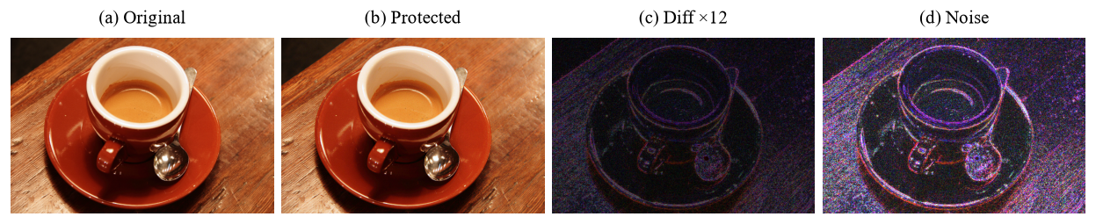
Fig. A.1 Protection of the Still-Life Image
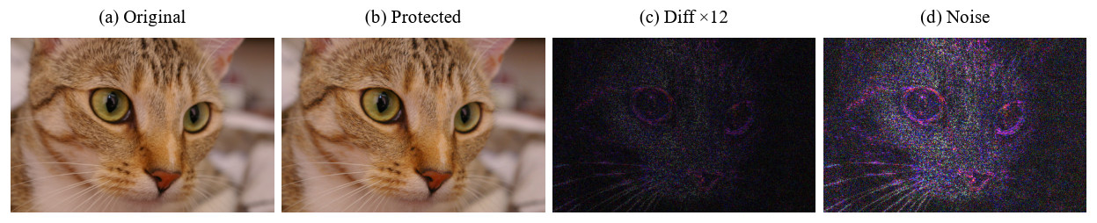
Fig. A.2 Protection of the Cat Photograph

